NATIONAL NUTRITION MONTH

Tip of the Week: Grow a veggie garden

By: Jacqueline R. Magana, PhD

WIC Chief Nutritionist Supervisor

3/24/2024

Vegetable Garden
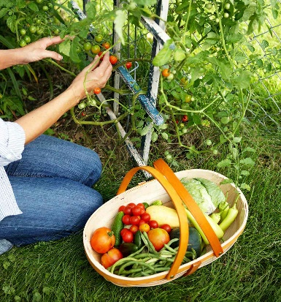
Growing a vegetable garden this summer is a great way to teach your kids about healthy foods. If you don’t have a backyard, the latest trend is patio gardening. You can grow your vegetables in grow bags and place them on your patio, balcony, or near a sunny window.
Start small, and you will soon get hooked and experiment with different vegetables. You may not be successful with some, but you may be with others.
Tomatoes, peppers, and cucumbers are some easy-to-grow vegetables. You can also try a variety of tomatoes, peppers, and cucumbers. Later, you can expand to try growing legumes like pinto beans or even some fruit, like strawberries.
You can purchase your plants that have already been grown in a garden nursery, or if you want to save money, try growing them from seeds. Remember to read the seed packet carefully; it has terrific information for successful growth.
After you decide what you want to grow and where you will put it for sunlight, now have regular watering and do not over water. Remember to fertilize your plants. You can mix coffee grains, eggshells, or banana peels with your dirt. Another option is to buy fertilizer that you can mix with water or, even better yet, start a compost bin with a lid.
Some companies sell compost starters, or you can just put some dirt in a bin and add your table scraps. Remember to only put vegetables, fruit, eggshells, and coffee in the compost bin. Please do not put animal products or by-products, as they will smell and attract insects. Compost turns food into rich dirt with vitamins and minerals that feed your plants. Usually, it takes a few weeks to a couple of months for it to process. But keep adding your table scraps to it, and you will have some excellent compost.
So, let’s get started!
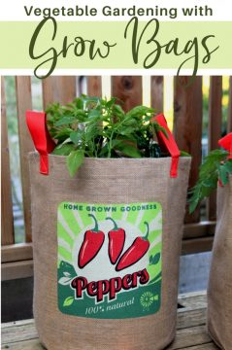

Harvest to Table on Grow Bag Vegetable Gardening.
Link How Long Does Compost Take (Plus How To Speed It Up) (compostmagazine.com)

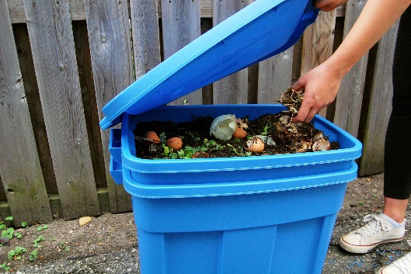
Compost Magazine on how to compost.
Link https://www.compostmagazine.com/how-long-make-compost

Resource:
Albert, S. (2024). Grow Bag Vegetable Gardening Guide. Harvest to Table: Food and Flower Garden.
https://harvesttotable.com/ grow-bags-best-vegetable-varieties-to-grow/

How Long Does Composting Take (Plus How To Speed It Up) (2023). Compost Magazine.
https://www.compostmagazine.com /how-long-make compost/#:~:text=The%20process
%20of%20making%20compost %20can%20take%20anything, into%20it%203%20what
%20you%20call%20finished%20compost%21

