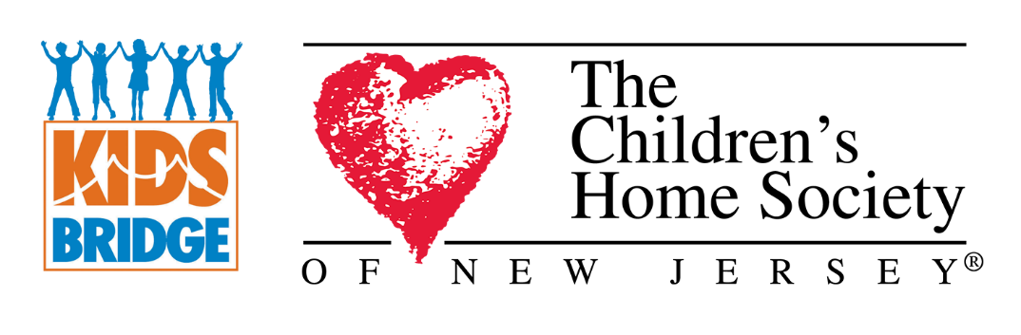

FOR IMMEDIATE RELEASE CONTACT: Lisa Thibault
July 1, 2024 609.273.7138
LThibault@chsofnj.org
Save the Date
The Children’s Home Society of New Jersey Announces the
17th Annual Kidsbridge Humanitarian Awards Celebration

What – Please join us as we honor four local individuals and organizations who help advance the humanitarian objectives of CHSofNJ and Kidsbridge to create a more tolerant, empathetic and bias-free community.
When – Thursday, September 12th 5:30pm-8:30pm
Where – The Stone Terrace by John Henry’s, Hamilton NJ
The Honorees –
Ross Wishnick, Send Hunger Packing Princeton
As a former home-building mogul and bank founder, Ross Wishnick has covered a lot of ground in his working life, though his true achievements shine through his service to his surrounding communities. Mr. Wishnick was a member of (2009 to 2020) and chaired the Princeton Human Services Commission, which provides services to youths and seniors in general assistance and advocacy for this segment of the local population. As part of this Commission, Mr. Wishnick took the lead on founding Send Hunger Packing Princeton (2013-present), which provides fresh produce for students and families requesting participation. SHUPP has grown to now include access to raised bed gardens throughout Princeton and Free Pantries constantly being restocked with shelf stable food, accessible 24 hours per day also located in number of locations throughout Princeton. Mr. Wishnick was also a member of the advisory board of the Princeton Education Foundation (PEF) (2010-2013). PEF supports excellence in Princeton Regional Schools by contributing raised funds for capital improvements, educational programs and teacher support. Ross Wishnick is a founding board member of The Bank of Princeton and has served as a vice Chairman since the bank’s founding in 2007. Most recently Mr. Wishnick has joined the board of Isles, a Trenton based non-profit founded in 1981. Its mission is to help support and sustain self-reliant individuals and families and healthy sustainable communities.
Natalie Tung, HomeWorks Trenton
Natalie is the Co-Founder and Executive Director of HomeWorks Trenton, a free community-based after-school boarding program. Growing up in a numbers-driven public school system in Hong Kong, Natalie had an unhealthy relationship with learning. This relationship changed when she had the opportunity to attend a boarding school in New Jersey. More importantly, living with 40 girls at such a young age empowered her to become more empathetic and confident, and these women are still her support system today. While earning her teaching certificate as a sophomore at Princeton University, Natalie started HomeWorks with the idea of replicating this experience for girls in marginalized communities around the world. Since 2016, she has built a diverse team of 9 staff members and over 50 volunteers. Together, they have expanded from a summer pilot to a school-year program with 70 participants and raised over $4 million in cash and in-kind donations. Natalie and HomeWorks have been recognized by McKinsey & Company, Camelback Ventures, Barclays, Comcast, Hollister, TRESemmé, Vital Voices, Penn Graduate School of Education, Princeton University, The Rachael Ray Show, New Jersey State Legislature and more.
Hindu-Jewish Coalition, Marc Citron and Fal Pandya
The Hindu-Jewish Coalition (HJC) mission is to build meaningful relationships between Hindu and Jewish communities on shared interests in political, religious, social, and other relevant areas through ongoing communications, meetings, events, and advocacy activities
HJC was created in 2013 by Rajiv Malhotra, Raghu Rao, Pinakin Pathak, Michael Feldstein and Marc Citron with a vision to create a unique multicultural collaboration. With a mission that features diversity appreciation, the HJC recognizes the shared interests of Hindu and Jewish people by taking action on shared initiatives. HJC celebrates an 11-year partnership of equals, of two strong and vibrant communities.
HJC Founder Marc Citron is a former managing partner at the Princeton office of Saul Ewing LLC. Marc is extremely community-minded having served on the Boards of B’nai B’rith, the Jewish Center, Greenwood House for the Aged, Bayonne Medical Center Foundation, JFK Medical Center Foundation, Sustainable Jersey, Eden Autism and received the National Judge Learned Hand Award from AJC New Jersey.
Fal Pandya serves on the executive board of HJC and is a passionate advocate for human dignity, focusing her efforts on promoting education, yoga, mental resilience through meditation, and the importance of cultural and interfaith exchange. She founded "Namaste Global" to inspire the next generation towards character building and a sense of global responsibility, all while maintaining a connection to their cultural roots. Fal Pandya has an MBA in Finance from NYU and is an investor in real estate and HealthTech start-ups. Currently, she is actively involved with the NJ-India Commission under Governor Murphy’s administration.
United Way of Greater Mercer County, Sandra Toussaint, President & CEO
The United Way of Greater Mercer County (UWGMC) connects people with resources enabling individuals and families to reach their fullest potential to create a thriving community. To advance this mission, the UWGMC invests in programs, community partnerships, and volunteer engagement in youth and family success, economic vitality and health and wellness. UWGMC President & CEO Sandra Toussaint leads a passionate and talented team working diligently to impact thousands of lives annually.

To purchase tickets or sponsorships, https://chsofnj.org/services/school-based-services/kidsbridge/kidsbridge-annual-gala/
For more information, visit wwwchsofnj.org or contact the Kidsbridge Humanitarian Awards Celebration Chair, Pam Cipriano, PCipriano@chsofnj.org.
Founded in 1894, The Children’s Home Society of New Jersey’s (CHSofNJ) mission is saving children’s lives and building healthy families. We achieve this mission through a continuum of supportive and preventative programs and services designed to protect abused or neglected infants and children; provide education and resources to strengthen and empower families; and help every child have a stable, permanent, and loving home.

