Adoption Profile:
Derek and Megan
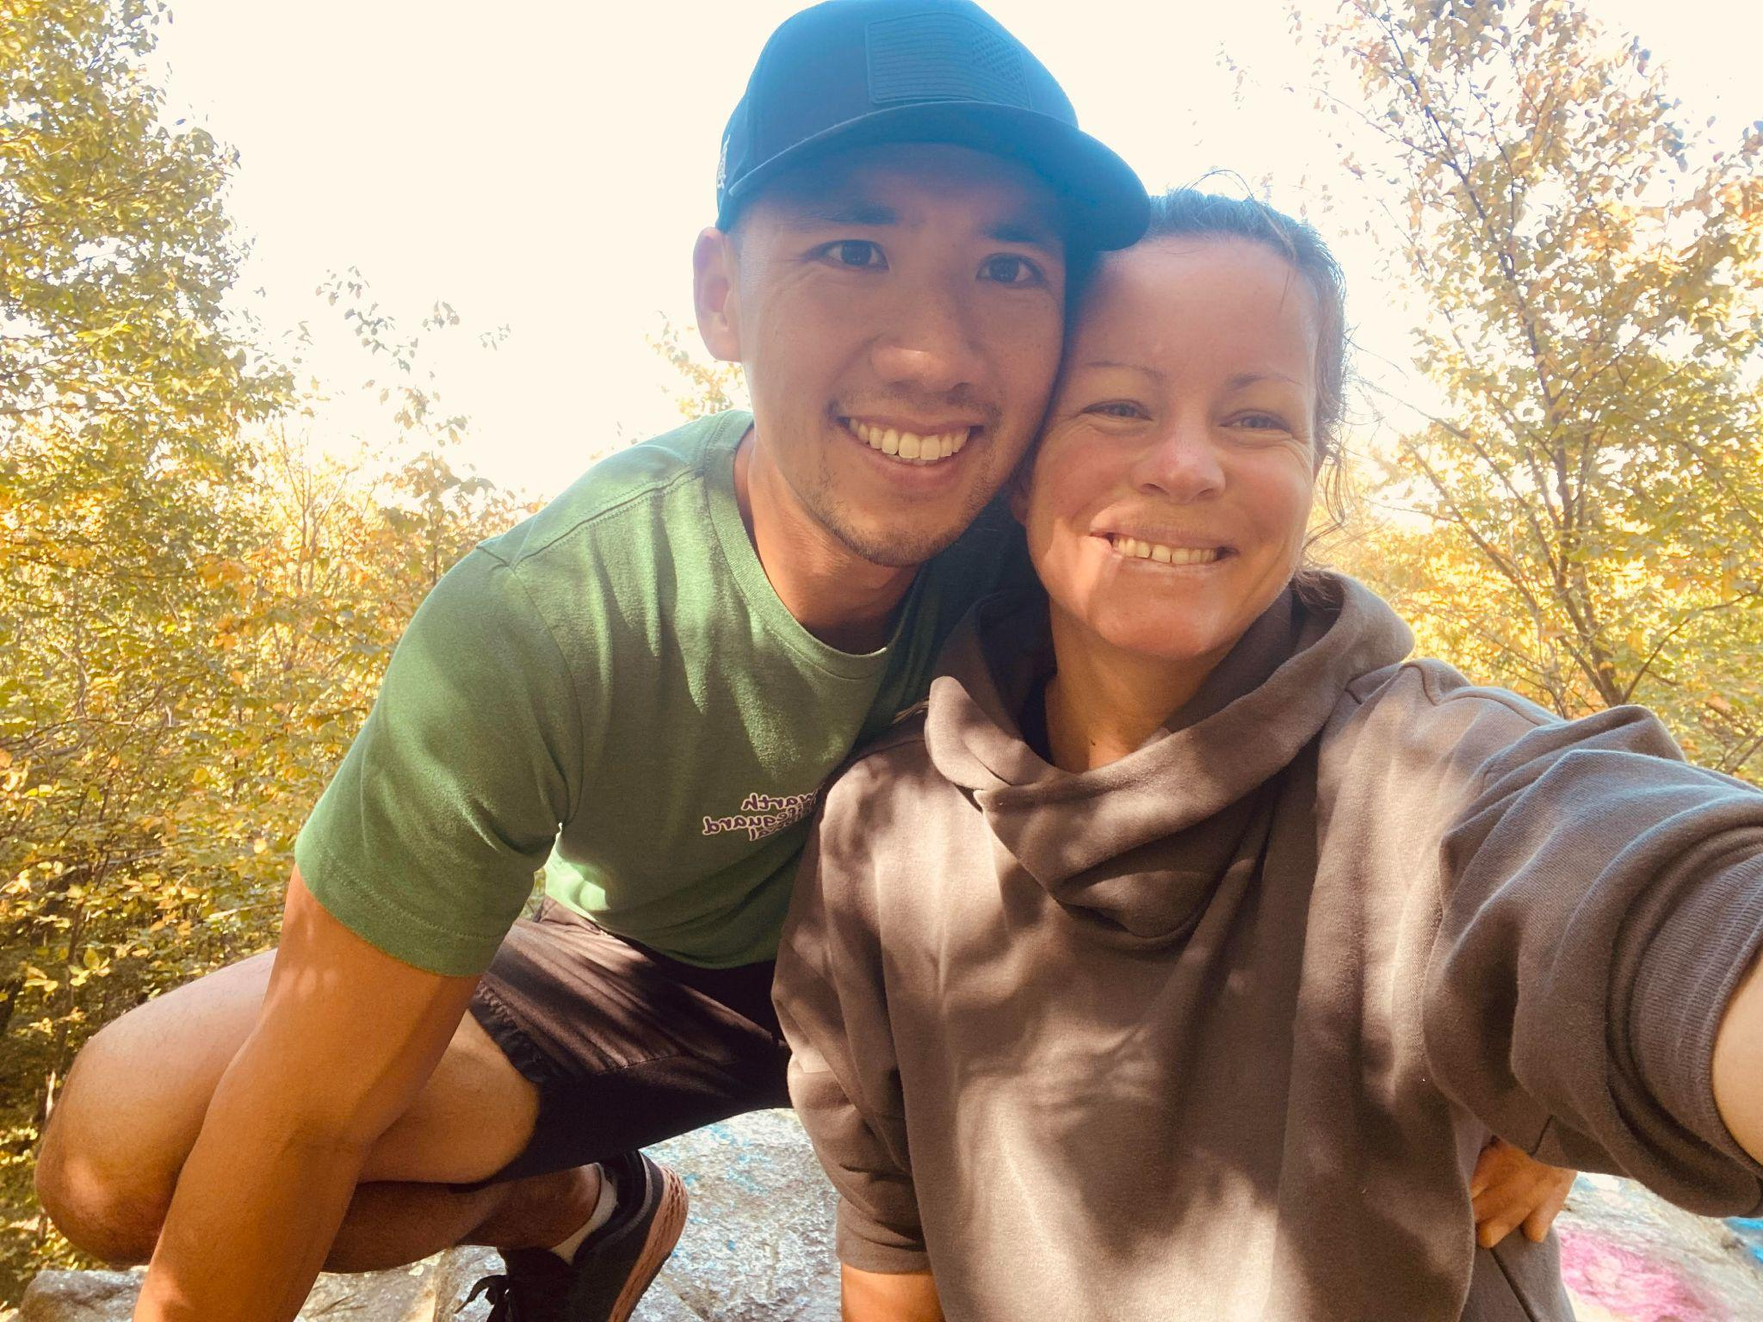

“Death of a dream”

“Derek, please return to the waiting area immediately. The surgeon needs to speak with you.” The text buzzed on the screen of my phone and made me freeze in mid-stride. I was cutting across the freshly paved stone courtyard of the University of Penn Hospital, trying to get some fresh air, away from the crowds of patients and loved ones sitting on cushioned chairs placed too close together in the waiting room.
Megan, or Meg as I call her, my wife for the last 10 years and my best friend for 14, was somewhere upstairs in the hospital. She was less than an hour into a routine surgery to remove several troublesome fibroid cysts on her uterus. It’s her third surgery of this kind in 2 years, these hidden fibroids have been causing her to bleed nearly daily for the last 5 years. She had been an absolute warrior through these past surgeries, the unforeseen complications and the tiresome recoveries. The constant prayer was that maybe like the bleeding woman from the Bible, Jesus would end her prolonged suffering (Mark 5:25-34). Staring at the message on my phone, it took much self-control to not let my thoughts race to conclusions as I spun around and moved quickly back towards the hospital entrance.
As I hustled past the brightly lit modern hallways up to the crowded waiting area, a sense of dread began to descend on me like gnarly dark thunderstorm clouds, gaining strength by the second and just waiting for the go ahead to unleash heavy, unrelenting rain. The usual smile was absent from the upbeat surgeon as she shuffled me into the private consultation area. She spoke in a direct but gentle way, professionally described in medical detail the ugly surprises she discovered on the operating table. Somewhere between “too risky” and “recommend a specialist”, the word “hysterectomy” entered the conversation. All I could do was to sit there and take it.
It felt, in that moment, an overwhelming, unstoppable flame had set fire to our dream of having our own family and all I could do was to watch it all burn down to nothing.
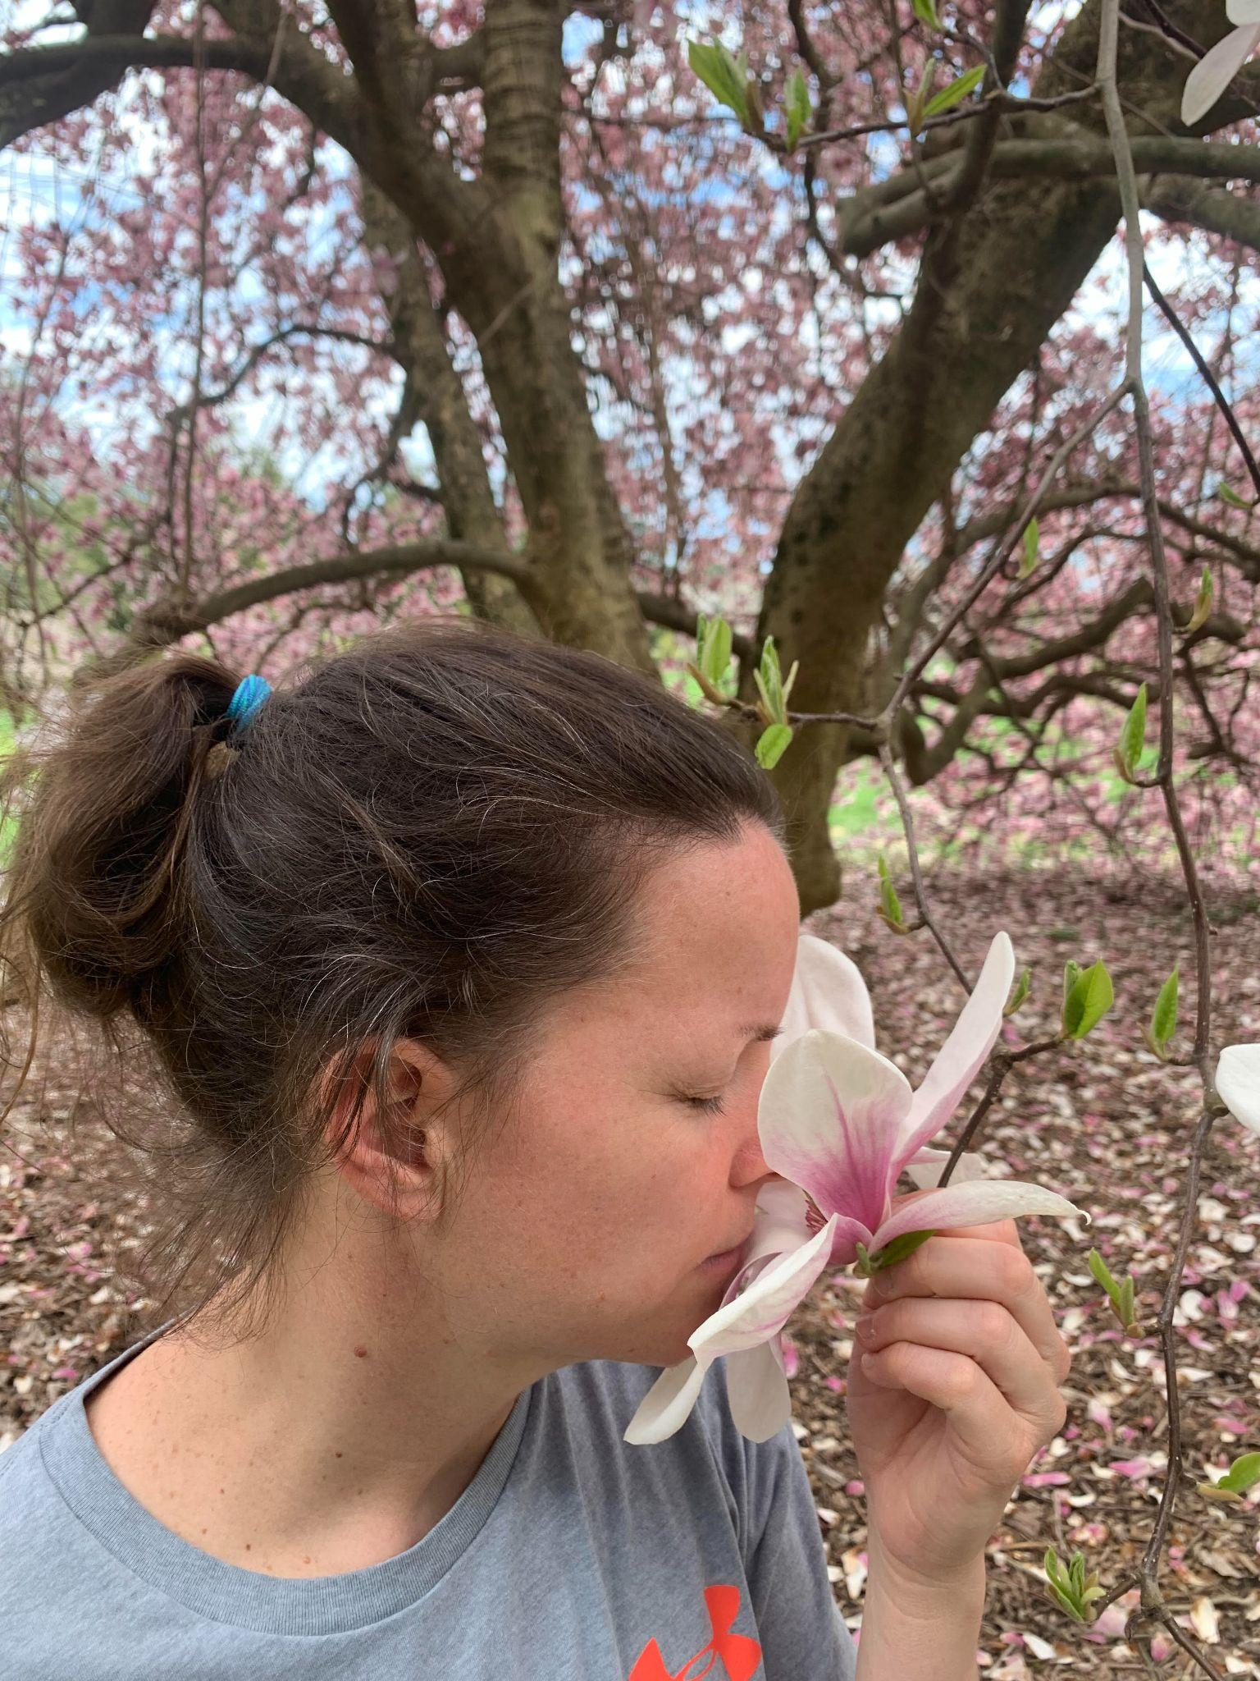
Two days later, Meg and I met with the specialist who confirmed the findings and recommendations of the surgeon. Imaging revealed several abnormally large tumor-like masses attached to the uterus and the risk of slicing out the damaged tissues without spreading potentially deadly cells to the rest of the body was overwhelming. After a thorough 2 hour long consultation, we thanked the doctor, quietly left the office and drove ourselves to a nearby public garden that was a former private family estate. We walked silently through the beautiful grounds, past the fields of trees and the ornate historical home that resembled a small castle. There, seated under a pavilion, surrounded by massive magnolia trees blooming with pink flowers, we made the hard decision to have the hysterectomy.
The complete removal of Meg’s uterus gave us the best chance to preserve her life and put a final end to her years of bleeding. It would also put to death our dream of having biological children that would be birthed from her body.
As we submitted ourselves to this life changing decision, we looked to the cloudless blue sky through long, wiry branches of fully bloomed flowers of bright colors, bursting with signs of life, hope and joy. With Meg’s head laying on my shoulder, I thought in my heart, “God, what are you doing with all this?”

Who we are (how we met, values and beliefs, work, hobbies)
How we met
What God was doing on a cool October night in 2008 was bringing 2 souls together.

It was the end of the weekly Thursday night Bible study, the 20 or so college students that just went through an hour of meaningful discussion and learning were now chatting about weekend plans and where to get some late night eats. It was my sophomore year and I had found a sense of belonging here in this Christian Fellowship since my first week as a freshman on campus.
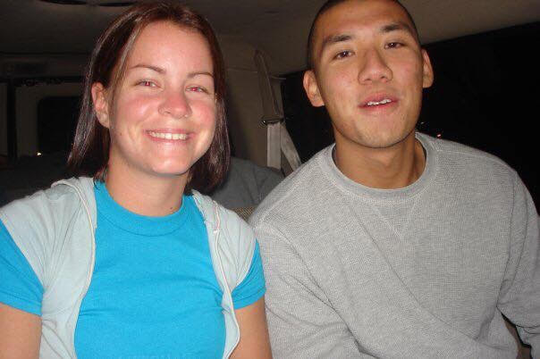
A sudden flash of someone walking past made me turn my head; I quickly wrapped up the trailing conversations about plans to go to a conference in Philly this Sunday and made my way after this mysterious girl. She must’ve been in the other study group on the far side of the hall for the last hour and was now making her way out. Although known as friendly and easy to get along with, it was still quite a stretch for me to take the initiative and go out of my way to introduce myself to complete strangers. But this time, something compelled me to, for once in my life, to make the first move. “Hey, I’m Derek. What’s your name?” The young woman, with soft shoulder length brown hair and loose yoga pants, turned and replied warmly, “Megan.”
Our first picture together in 2008

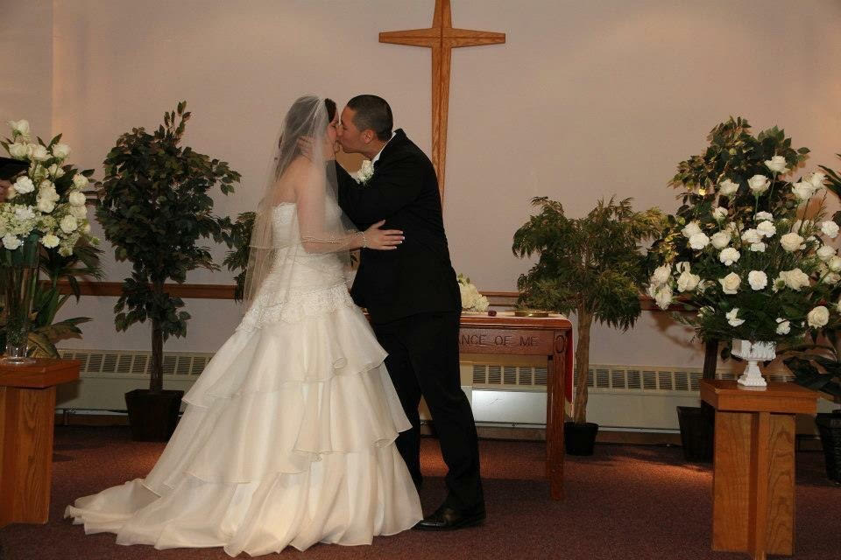
That 5 minute conversation in the middle of the glass door way between F and G Wing of Stockton University’s academic building evolved into a dating relationship a month and a day later. And 4 years after that, on a strangely warm 55 degree sunny day in January, Meg and I committed our lives to one another in marriage in front of God and a crowd of friends and family.

Values and beliefs
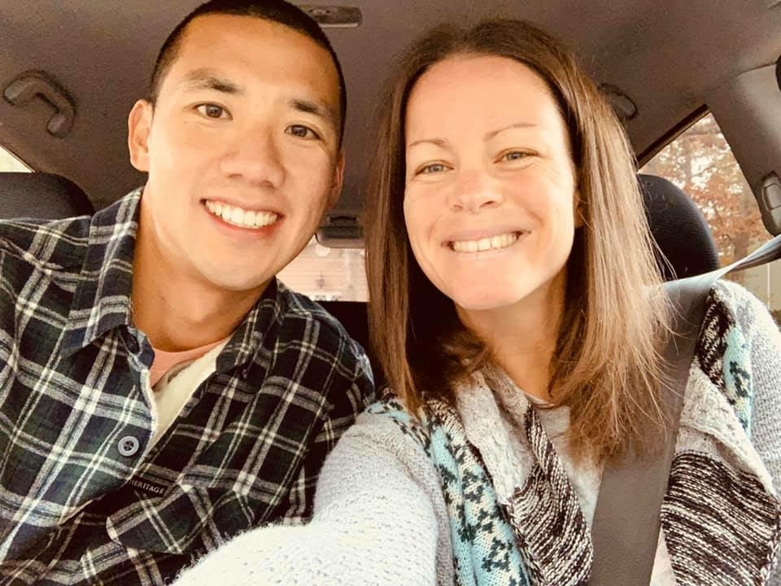
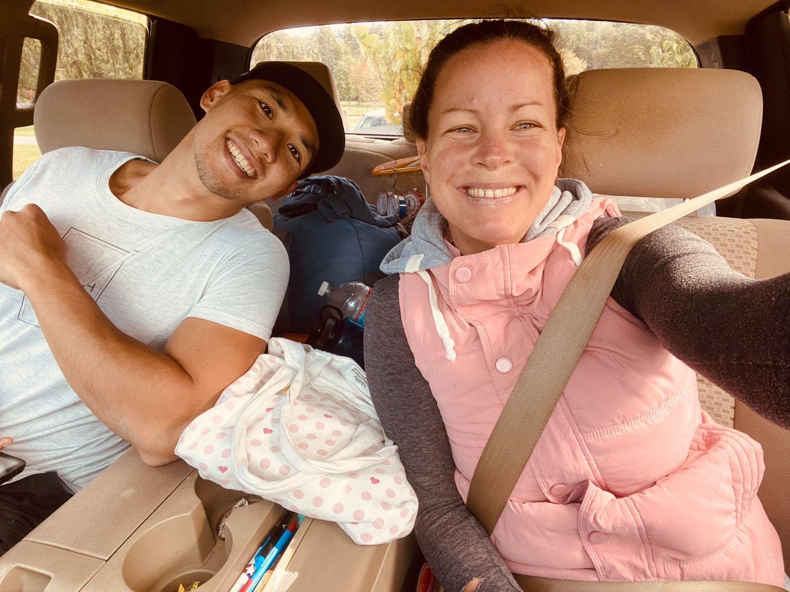
In the most central part of our lives, the deepest part of who we both are, the core of what makes us, “us”, is that we are both followers of Jesus. It’s not that we only drag ourselves out of bed on Sundays to make attendance at church, or that we try our best to do “good” and avoid “bad”; but it is because of our personal experiences of what God has carried us through and the lengths that He has gone to make us His own that fills our hearts with love and energy to follow in His way and see all things through His view.
Work

We see the value in working hard with all our strength and energy, in such a way to thank God and also to trust Him with the results (Col. 3:23-24). All that we have is from Him and we live to be good stewards of these gifts. It would be a lie to say that each moment of each work day is filled with endless joy and purpose or that we never had coworkers who drove us crazy. But what’s beneath the surface of the triumphs and conflicts between clock-in and clock-out is that we see work as a way to interact with the people around us, an opportunity to contribute to the community and to engage in meaningful relationships with others.
Meg works as an upholstery fabricator at a family-owned boating accessory supplier; together with a diverse group of ladies, they tirelessly labor each day to create hand-made custom cushions, covers and furniture for extremely high end boats. From the massive wooden work bench, she meticulously cuts detailed cushion patterns out of raw fabric and then carefully stitches intricate pieces together with her skillful work of the sewing machine until the final product of beautifully hand-crafted upholstery is produced.
Derek is a HVAC mechanic at the school they met, Stockton University. Every day, he patrols around the campus; with worn-out wrenches in hand and power drills clipped to his belt, going through mechanical closets, boiler rooms and rooftops to inspect, maintain and repair HVAC equipment. The manual work can be physical and the exposed conditions can be harsh, but he takes pride in being a bit chilly in the winter and quite sweaty in the summer to keep all the professors and students safe and comfortable year round.
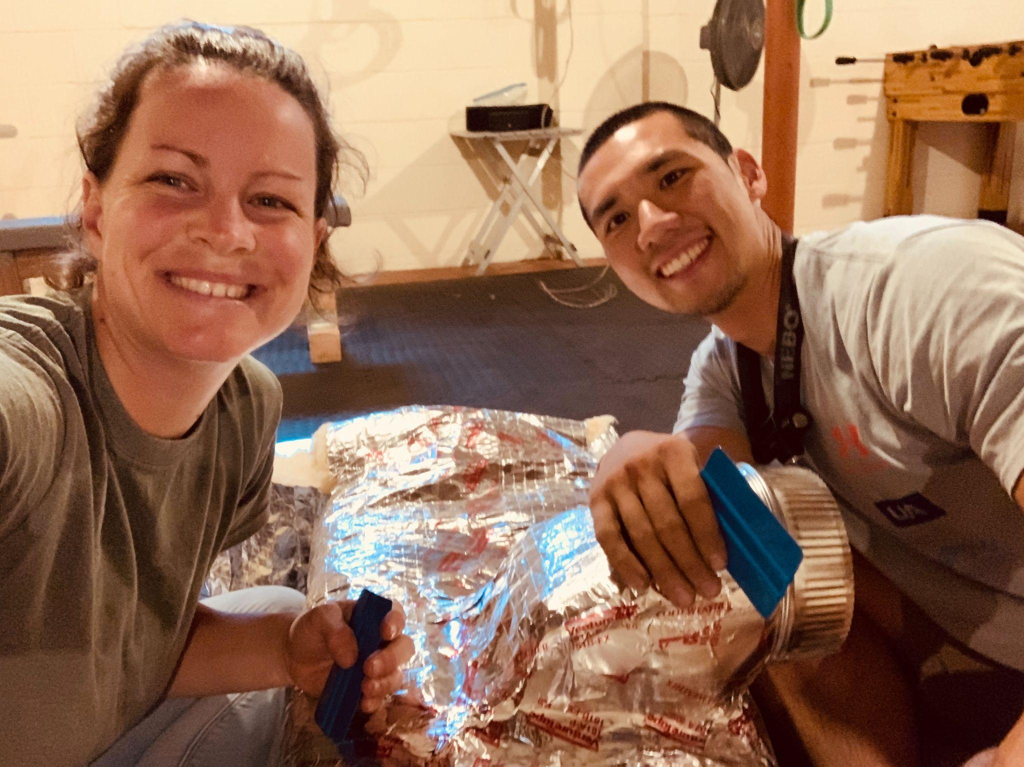
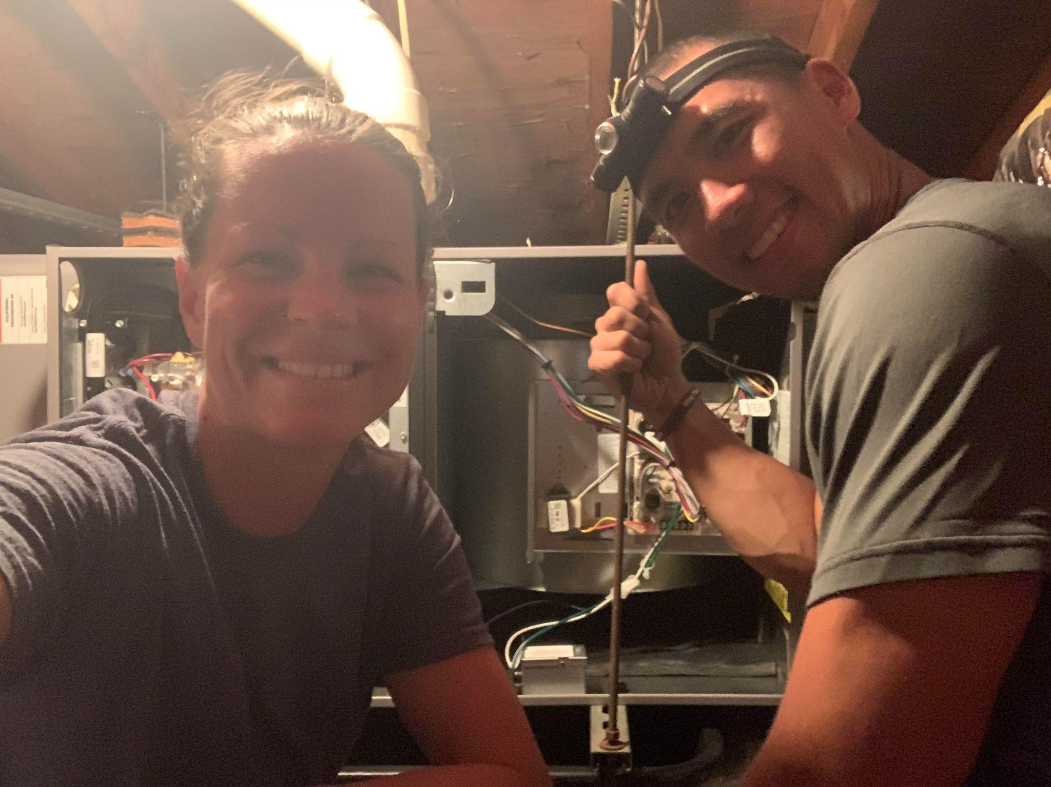
We also have a side HVAC business together, Meg would throw on t-shirts and sweats and worked side-by-side with me in brutal conditions. We have been in scorching hot attics and damp, nasty crawl spaces changing out heavy equipment and repairing ductwork. We enjoy hard work and all the rewards that come with it. We even installed the entire central heat and a/c system in our own home together!

Hobbies

Outside of work, we love staying active by being outdoors and in nature. A few times a week, we go for long walks or bike rides around the parks and fields in our neighborhood. During the Covid pandemic lockdown, we built a custom home gym with wood beams, metal pipes and old weight equipment from our family. Before the sunrise or after the workday is done, one of us would be in the basement getting a hard workout in, to the tunes of 80’s road trip music or some epic worship songs.
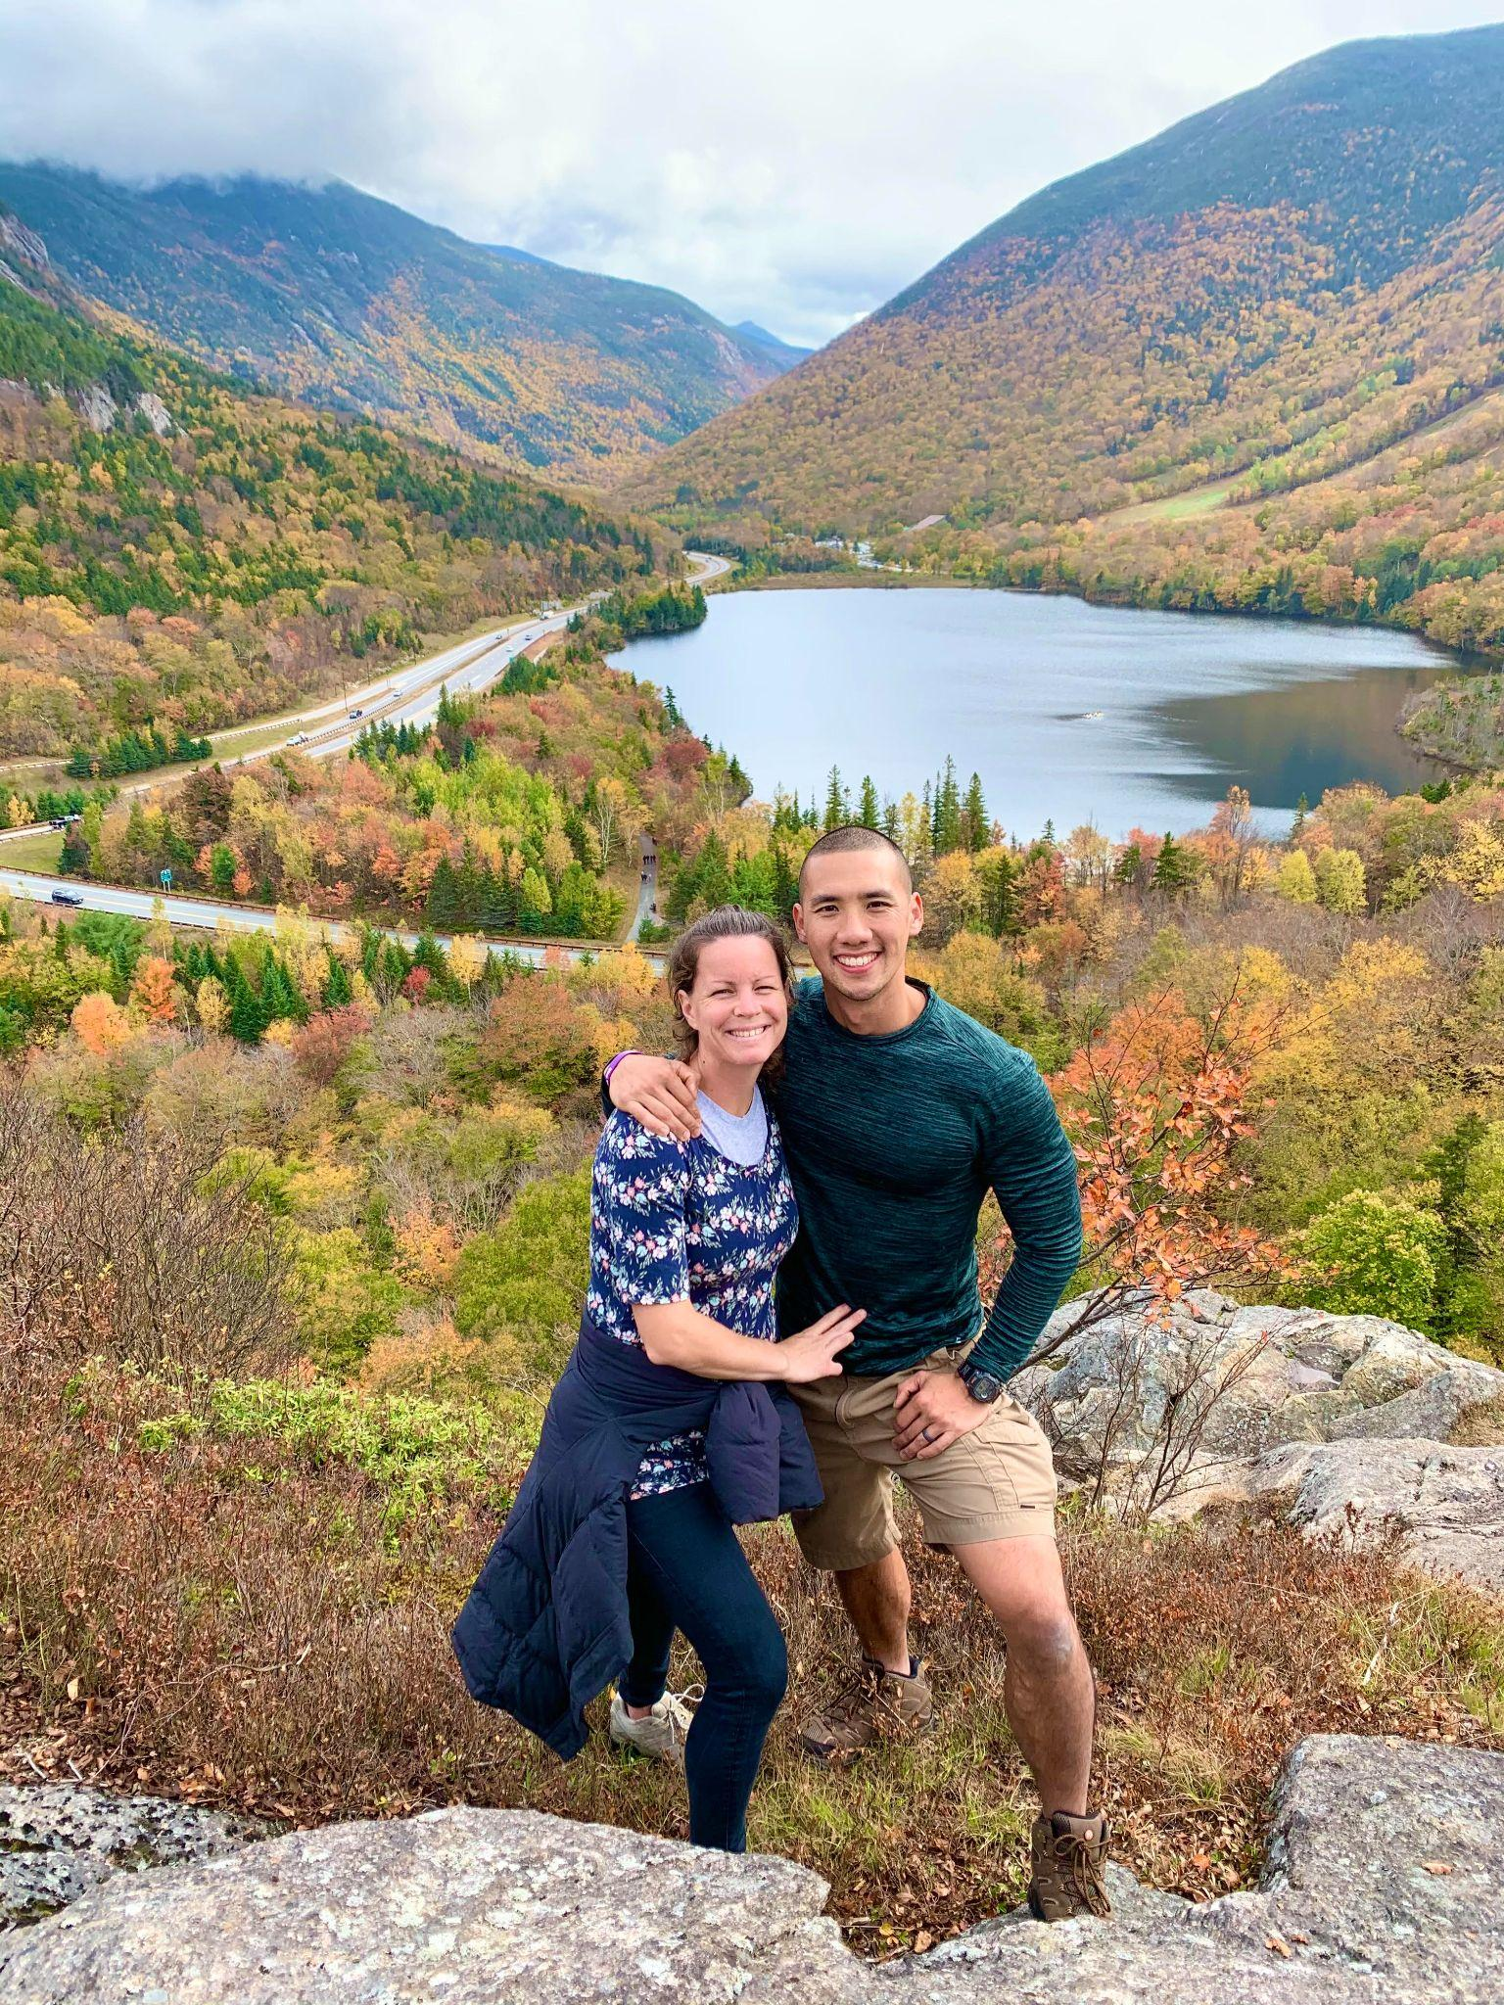
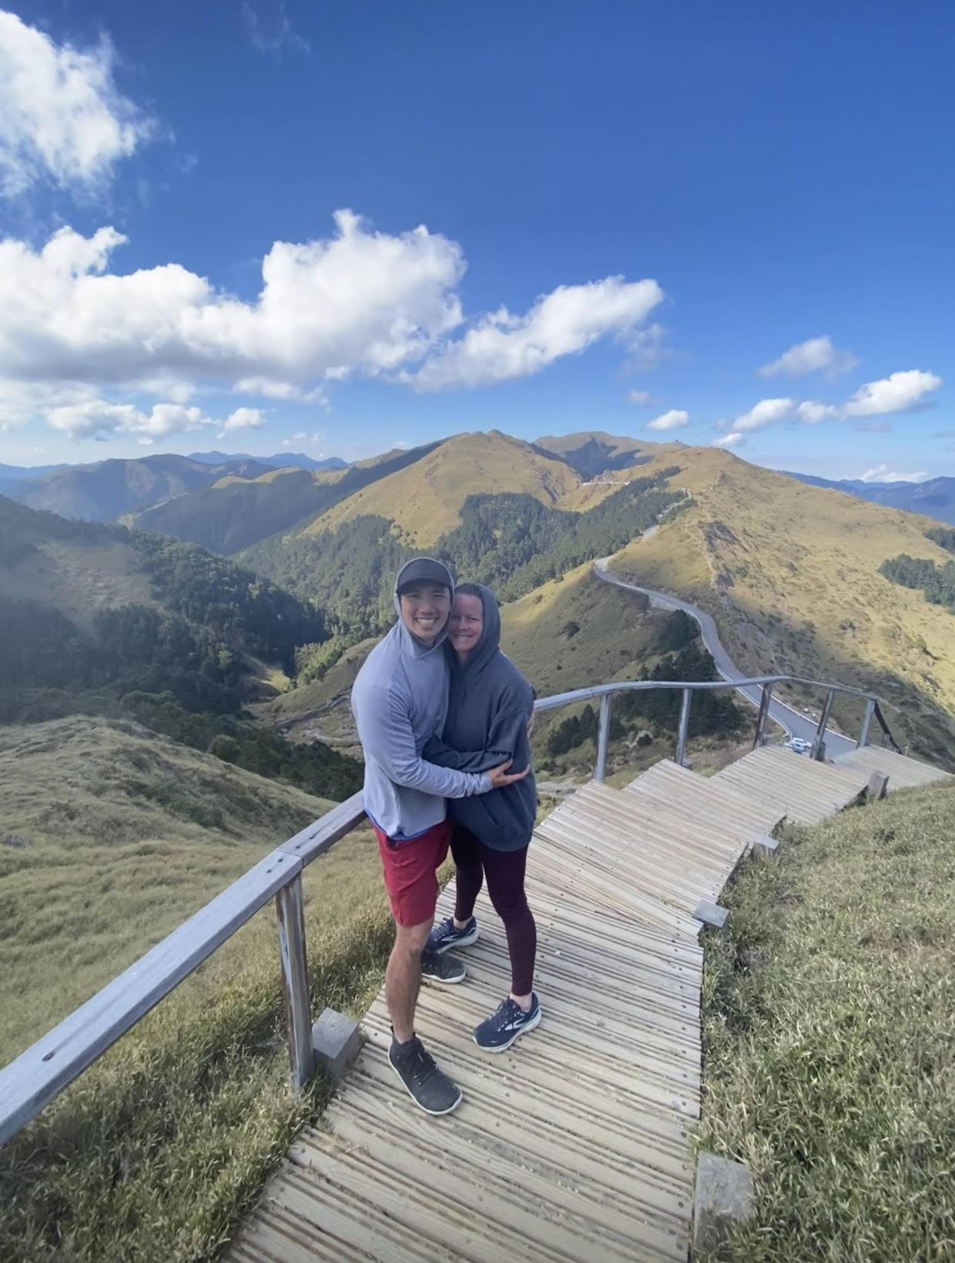
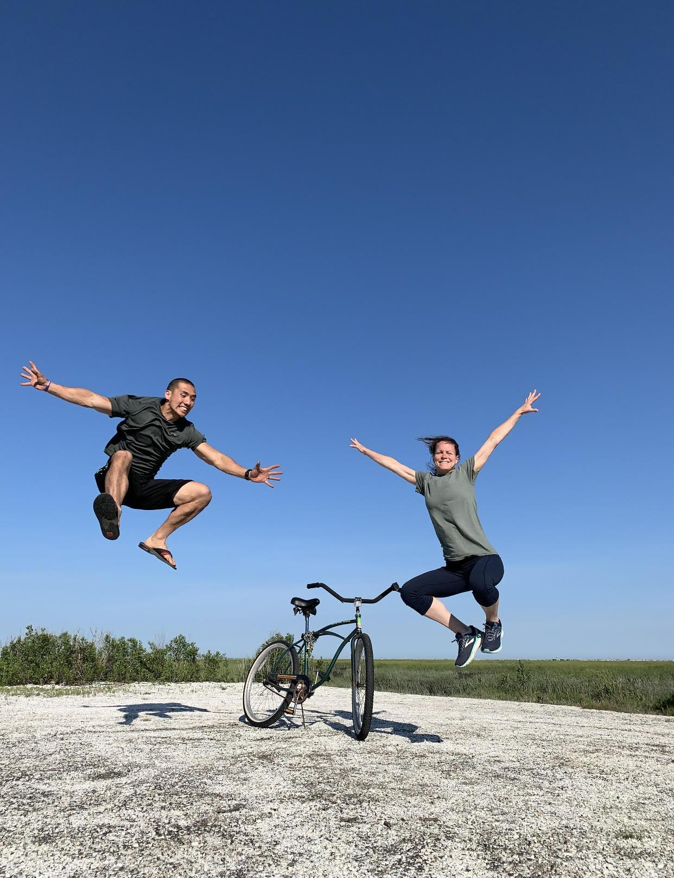

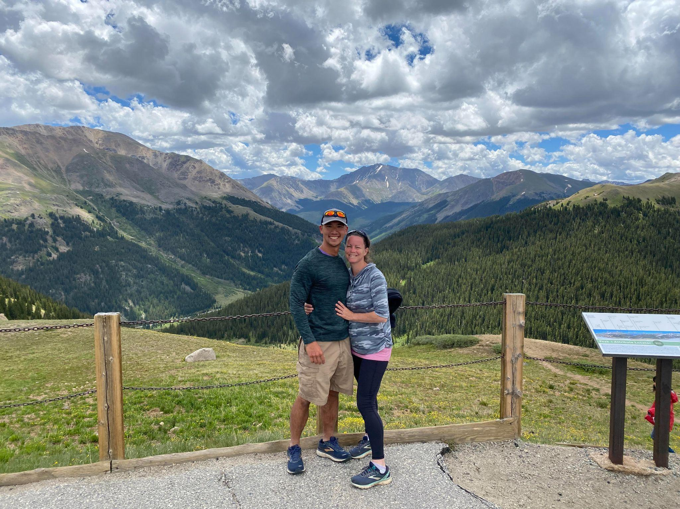
We also find opportunities to go away on extended trips, embark on adventures, take scenic drives, and have unforgettable experiences. The beauty of oceans, lakes, mountains, valleys and all the wild life reflect the beautiful heart of the Creator that placed them all there. We have witnessed the morning sun rising over the backs of the blacked out mountain chains, bursting forth with brilliant light, bringing to life instantly the valleys before us. Our backs have felt the awesome force of roaring waters pouring over us as we hiked through massive waterfalls. Great trees of bright colors of yellow, orange, red and more have been our backdrop when we trekked through wondrous forests and Great Plains. All of these adventures persuade us time and time again just how caring and kind our God is, that we not only exist, but we live in a place that He has masterfully crafted for us to enjoy.
We love the mountains!
Meg especially loves snapping pictures and recording videos to capture these special moments we’ve experienced. There’s no better way to cherish the beautiful views our eyes had seen and the wonderful people God had put in our paths. These memories are forever captured in photos and videos.
Most days we stick to our healthy eating routine, grilling up juicy ribeye steaks, steaming up broccoli and chomping down fresh local blueberries. But once a week, we make a point to go and splurge on some good eats. Buffalo wings with extra sauce, fresh Italian subs with local bread and authentic Mexican foods are a few of the favorite things we indulge in. Coupling the delicious eats with a movie of good value and character in the comfort of our home is our go-to recipe for a great date night.

Our family (upbringing and family values, family members and relatives)

Upbringing and Family values

Meg’s family has lived in the shore town of Ventnor for the last 75 years. Faith in Jesus has always been the central value that encompassed every aspect of family life. Born to a humble, calm, strong, loving father and a selfless, positive, caring, loving mother, Meg, the youngest of 3 close-knit girls, remembered her childhood home as fun, loving, warm and safe. The values of faith, family, love, togetherness and helping each other were vital to the strength of their family bond. Being active in a local home church and young life youth group was important, but her parents further stressed how essential it was to have a personal faith in Jesus.
With her father as a firefighter, high school swim coach and the captain of the beach patrol, together with her mom as a middle school special education teacher, Meg’s family was an integral part of the town. In one way or another, nearly everyone in town could trace their connection to her family. Countless swimmers have been coached and mentored by Meg’s dad, her middle school gym teacher was the husband of her mom’s childhood friend, and that a good portion of the town’s residents had their lawn maintained by the men of Meg’s extended family for three generations.
She was also blessed to have grandparents who were a few streets away. Sleepovers at Grandpop and Grandmom’s were a regular occurrence. After a full dinner of Italian subs with fresh cut salami, cheese and iconic, local Italian bread, sweet Grandmom would softly scratch their back while singing nursery hymns as they drifted off to peaceful sleep.
Childhood memories of summer in Ventnor were truly special. Even now, on any given decent summer day, there’s a fair chance that several members of Meg’s family and friends could be found on the beach.

Derek’s upbringing could not be any more different than Meg’s. He was born on the other side of the world, 8,000 miles away, in the Asian country of Hong Kong. Although the country is roughly 3 times the size of Philly, it has 5 times the amount of people. Derek lived there with his parents; a reserved father who was a quiet, hardworking businessman and a mother who was an avid gardener and seemed to make friends everywhere she went. His younger brother came 3 years later, exactly to the date (Derek and his brother share the same birthday). As with many other families trying to better their lives in a densely populated city, his parents worked hard to provide the best life for their sons; dad spent long days exploring different business ventures and mom picked up odd jobs in between raising the two young boys.
In the typical Asian culture, love was not expressed in warm hugs and soft kisses but in the abstract forms of material and physical provision for one’s children. A father would work months on end without a day off for his family and a mother would often be savoring on scraps of food after her family had finished their meals.
Being in a major metropolis, Derek learned quickly the hustle and bustle urban lifestyle as a young toddler, grew accustomed to always waiting in long lines, whether for traditional BBQ roast pork over rice or simply to relieve an overfilled bladder. He also got used to the art of “dipping” instead of “swimming” in public pools because the people to water ratio was always way off; the pools were never big enough for the multitudes of people.
When Derek was 6, his family moved to the neighboring country of Taiwan, his mother’s home country. There, Derek quickly picked up the smarts that was required to get around. Spending an entire day out in the city, riding the subway from town to town to grab fried dumplings and sip on bubble tea with a handful of friends was a typical day for the 10-year-old Derek when he wasn’t in school.
His mom had a large extended family there and Derek and his brother loved visiting grandma's place in the country during epic Chinese New Year’s festivals. It was a multi-day celebration of the start of the Chinese calendar year. Adults would walk around with red envelopes filled with money inside, upon hearing phrases of favorable new year’s greetings, the red envelope would be transferred to the excited kids. The two of them would go around with their older boy cousin, raking in red envelopes, gorging on grandma’s homemade Taiwanese noodles and setting off a questionable amount of fireworks across the rooftops.
Major shifts again took place when Derek was 12 when his family took the opportunity to come to the US for a chance of a better life. The familiar dumpling restaurants, convenient subway stations, traditional tea shops in the back alleys were replaced with well-maintained suburbs, grand shopping plazas with drive through and massive big box stores with endless aisles of goods.
Derek struggled with fitting in in this unfamiliar country with unfamiliar people speaking unfamiliar languages living unfamiliar lifestyles. Eventually, through a string of divine happenings, Derek found himself on a 4 hr. bus ride to a week-long Christian summer camp. It was in this camp that he encountered the God that had personally created him and promised to never leave or forsake him. His faith remained a central part of life throughout the ups and downs of high school. In due time, the belief in the Gospel began to take solid roots in his heart as he prepared to leave home to move out to college.

Family members and relatives

Just as God deeply values life and relationships, we too strive to live out our belief that relationships are the most important things in life. It is for the sake of relationships that people make life-altering decisions, cross wide oceans, leave behind homelands and sacrifice everything they own. We see life as a precious gift that is not to be wasted but to be cherished. How we use our time, the places we go, the activities we do, the items we buy or don't; all these decisions get filtered through the lenses of how we can best thank God for the life He has given us.
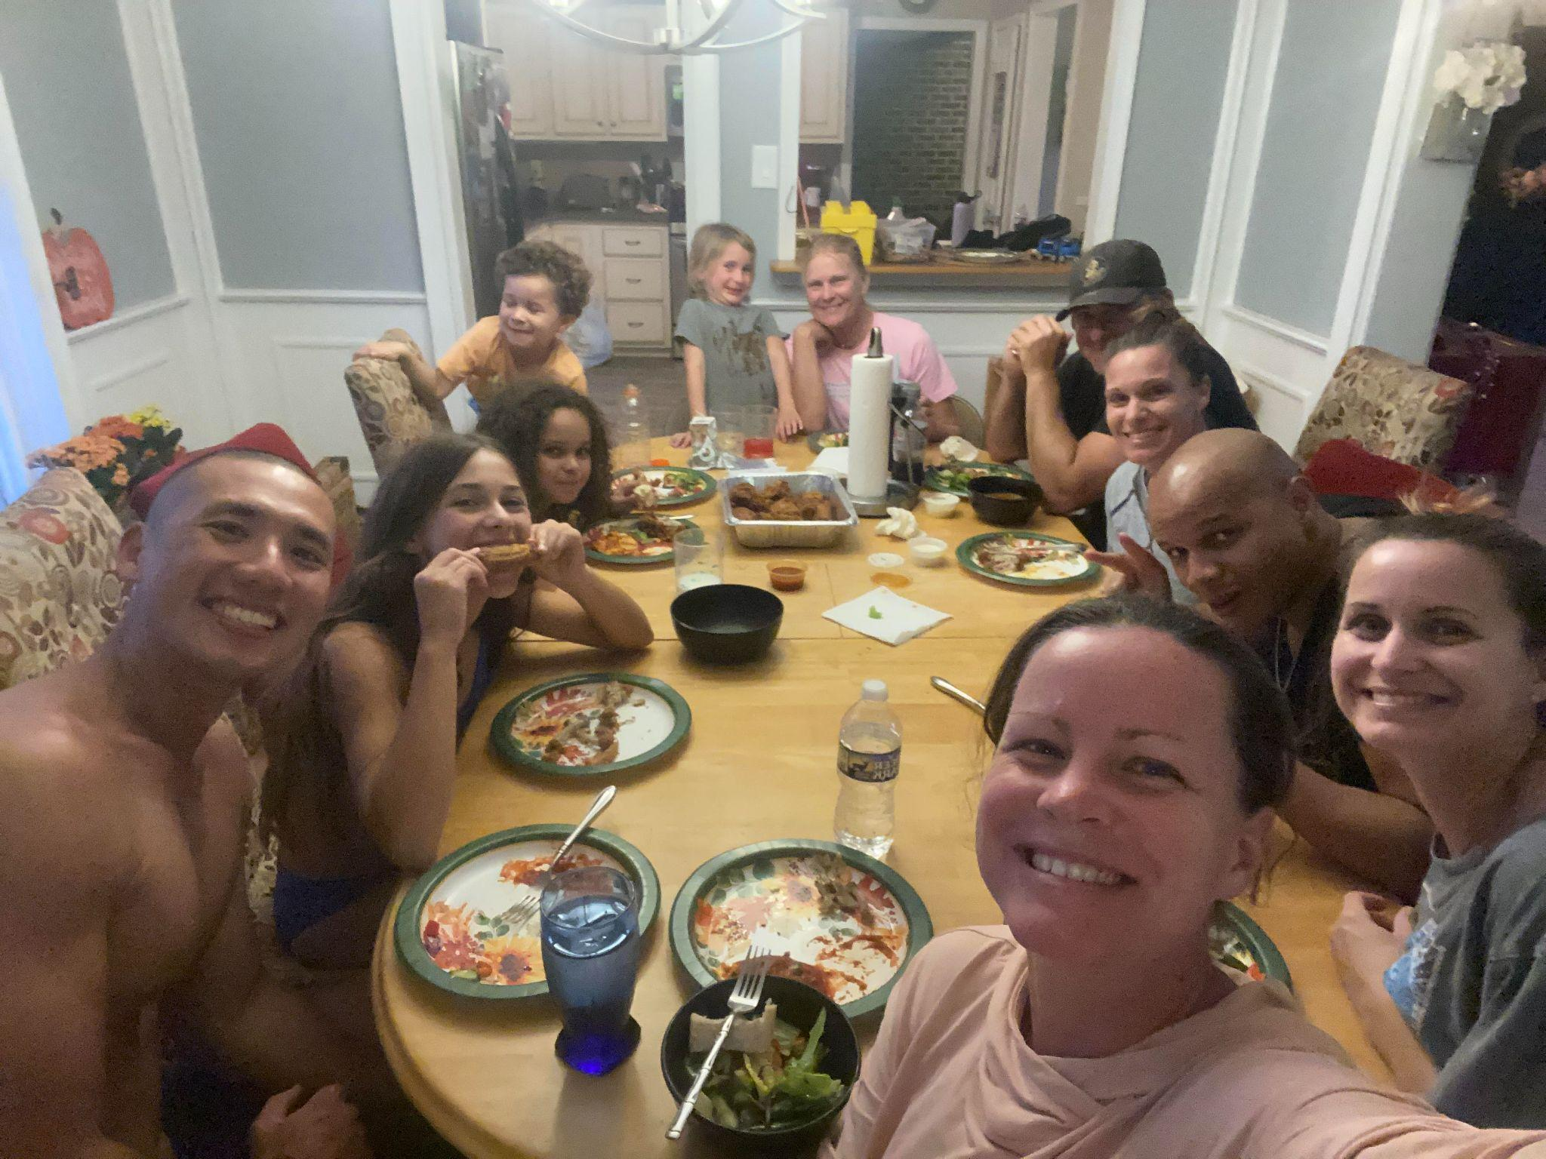
Although Meg’s family has multiplied greatly in size, they are still all very close and gather often. Very few of Meg’s extended family moved more than 30 mins away from Ventnor; cousins, aunts and uncles were always present at birthdays, anniversaries or any excuse to meet and have family dinners.
A typical family dinner involves adults trying to eat with all the rambunctious nieces and nephews around the table, one would be sitting nicely, another one standing on tippy-toes on a chair singing and without naming any names, one would be spitting kernels of corn everywhere.

Derek has fewer family members in the states and we live further away from one another so it’s extra special when we have opportunities to get together. An abundant amount of homemade traditional Chinese food would be served whenever there’s an excuse to gather and eat. The now 30-something year old adult male cousins would easily slide back to their childish ways when they were together; egging each other on silly acts and one-upping the other on goofiness.
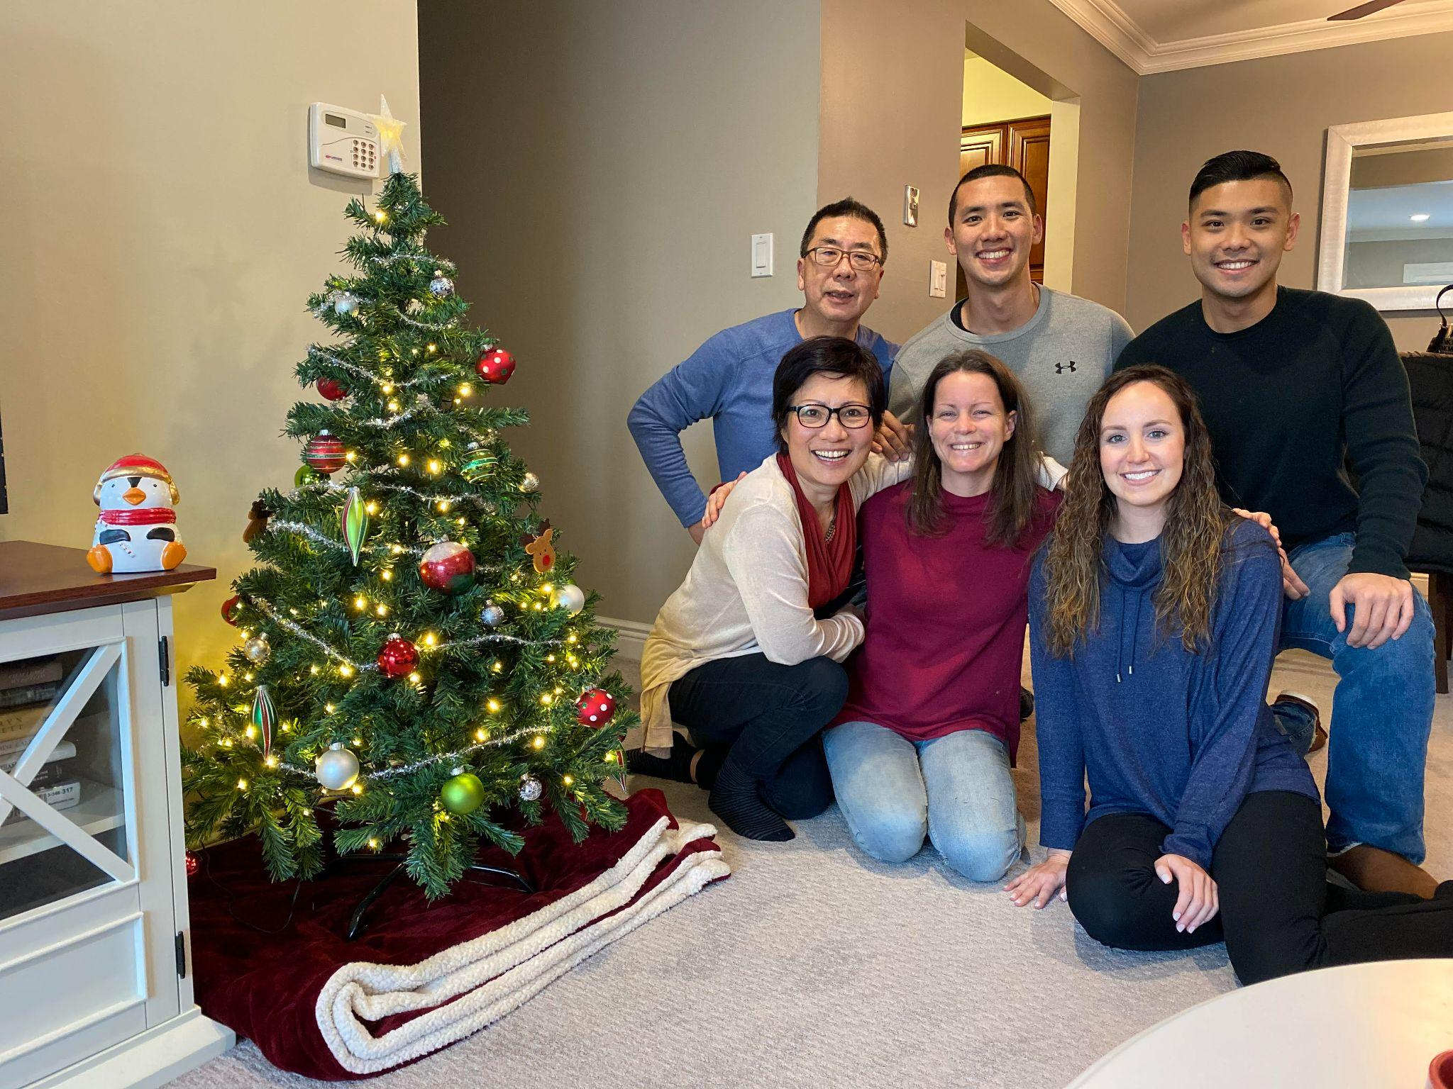
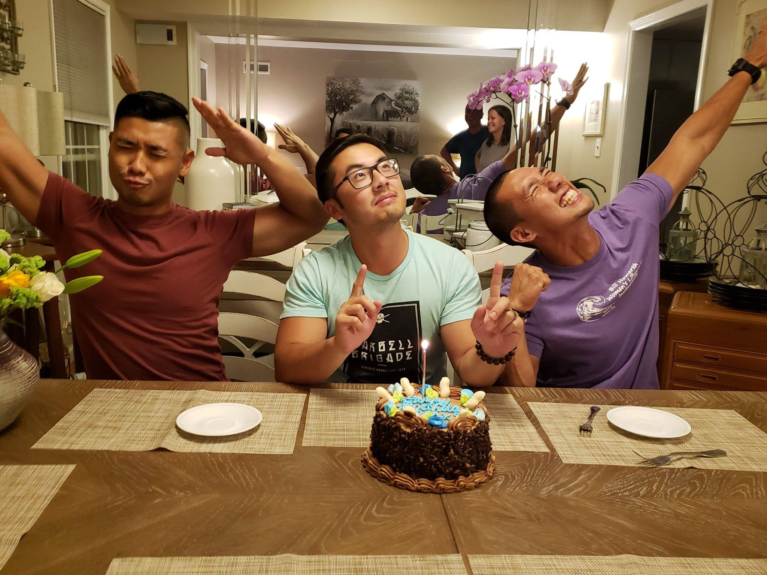
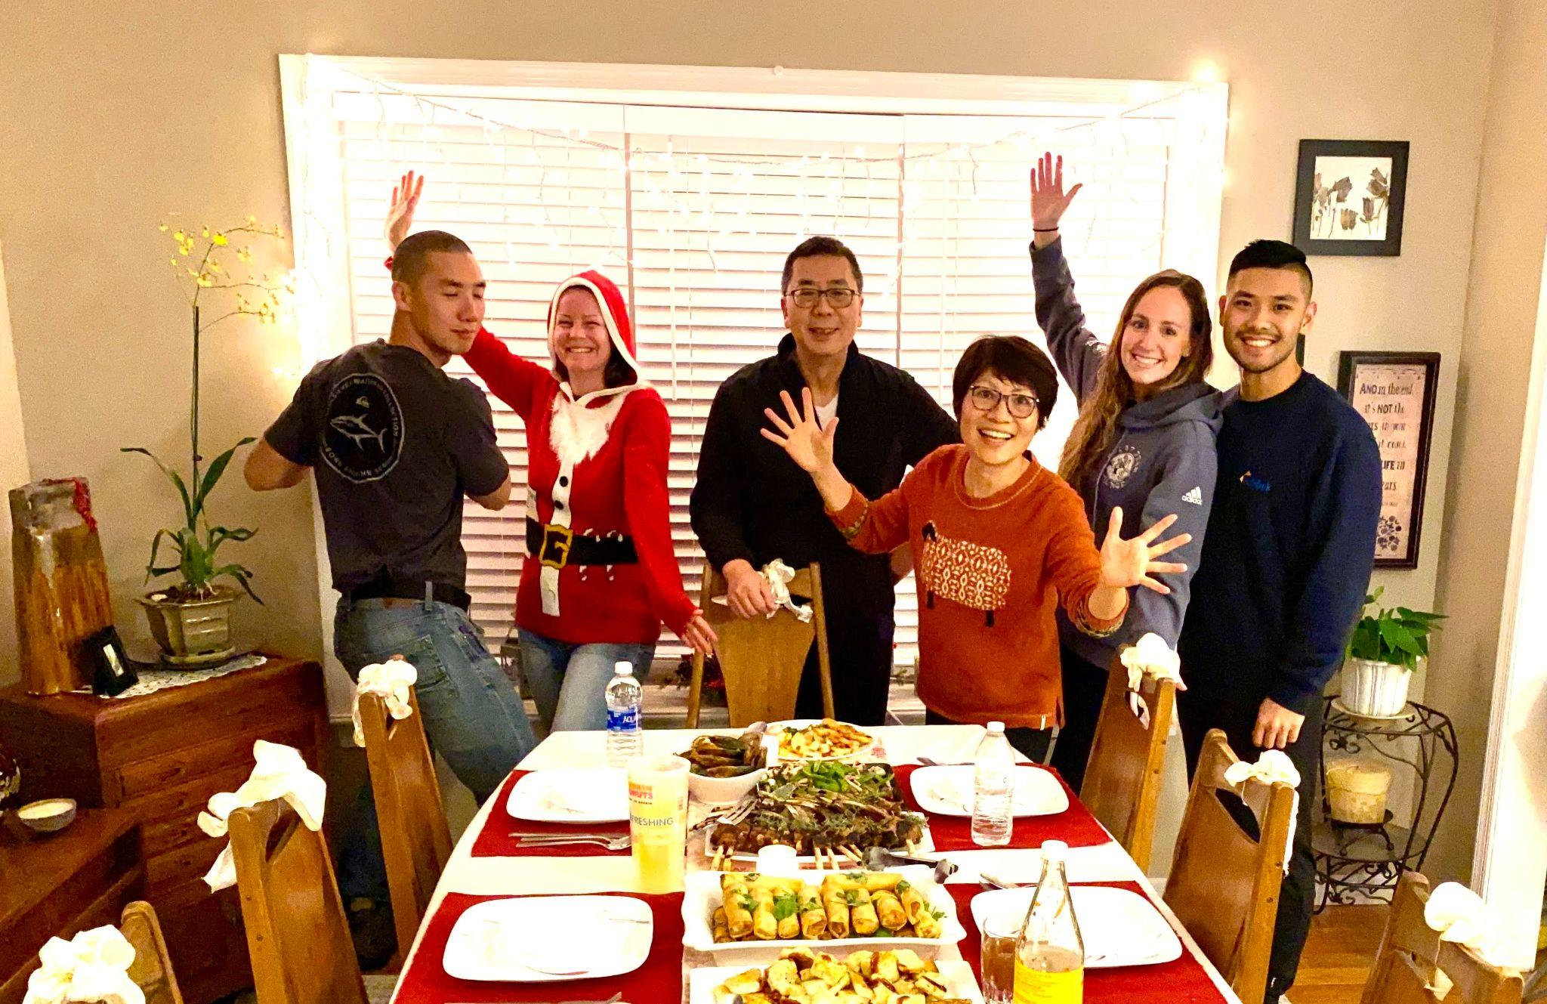
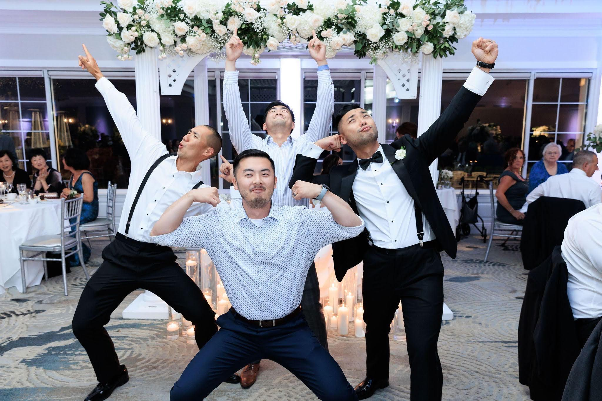
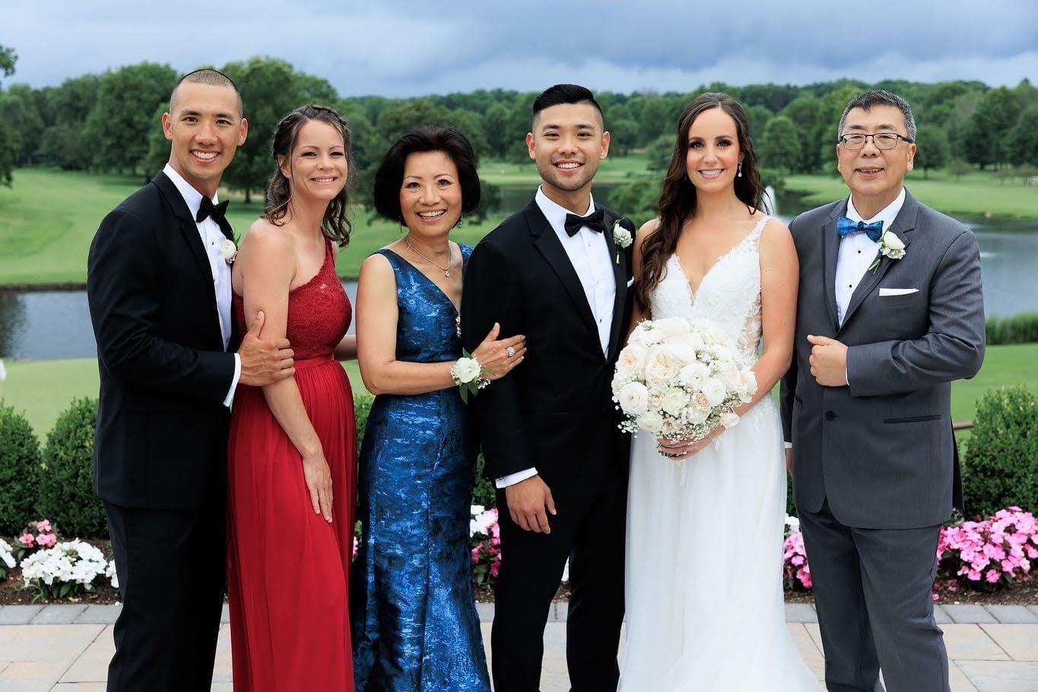
Celebrating Derek’s brother’s wedding day
When the cousins get together
Summertime is always a highlight with Meg’s family. If her family isn’t at Mom Mom’s pool, ski beach or the playgrounds, then they are most certainly at the beach, at the specific street in Ventnor they have gone to for decades. Once the 2 truckloads worth of beach gear is dropped off on the soft, grainy sand, the kids run off to their favorite place to be this time of year. The big kids are way out in the ocean on sleek surfboards, catching waves and wiping out, and the little ones are digging and piling on sand to form massive sand castles or making mermaid tails on each other’s legs out of sand. We just love days like that, floating in the cool ocean waters, tasting fresh lemon popsicles from the local ice cream vendors and enjoying the wonderful blessing of nature and family rolled into one.
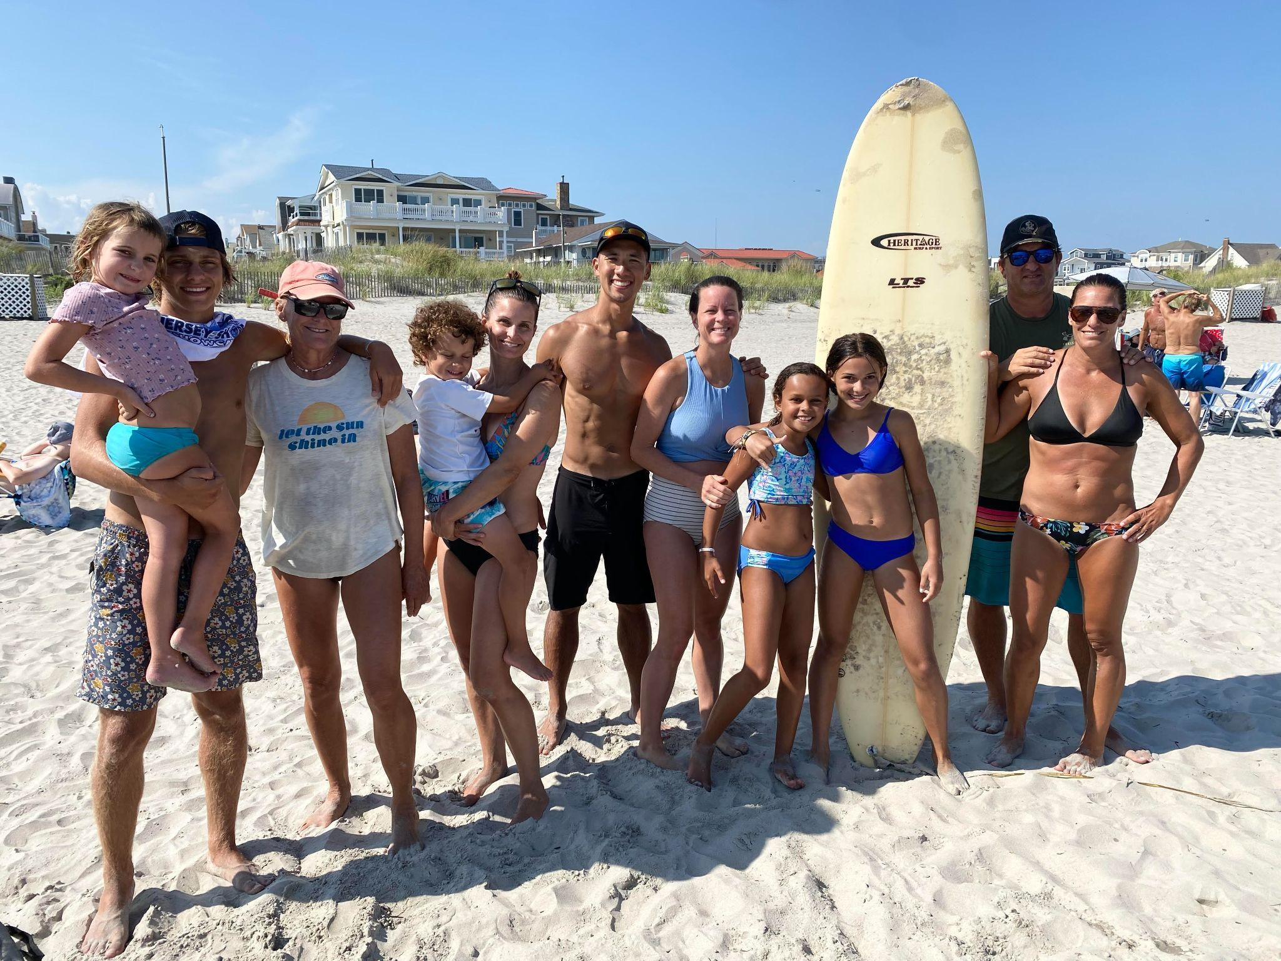
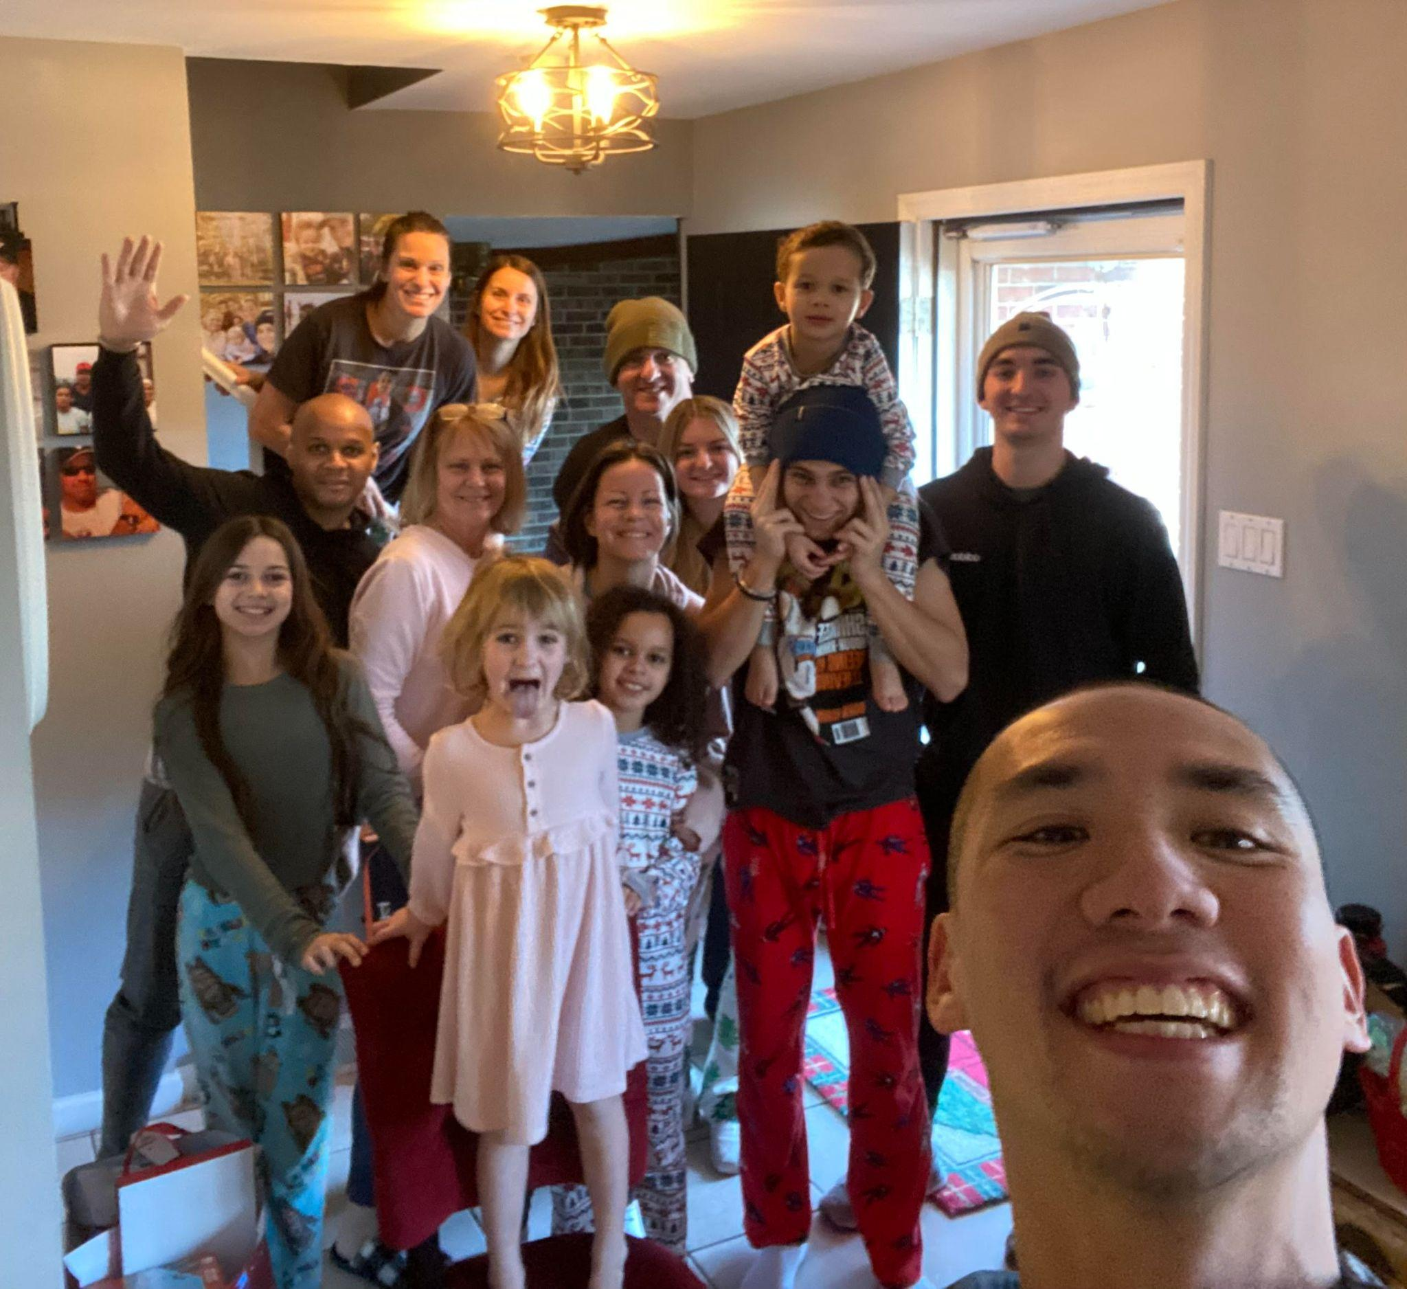
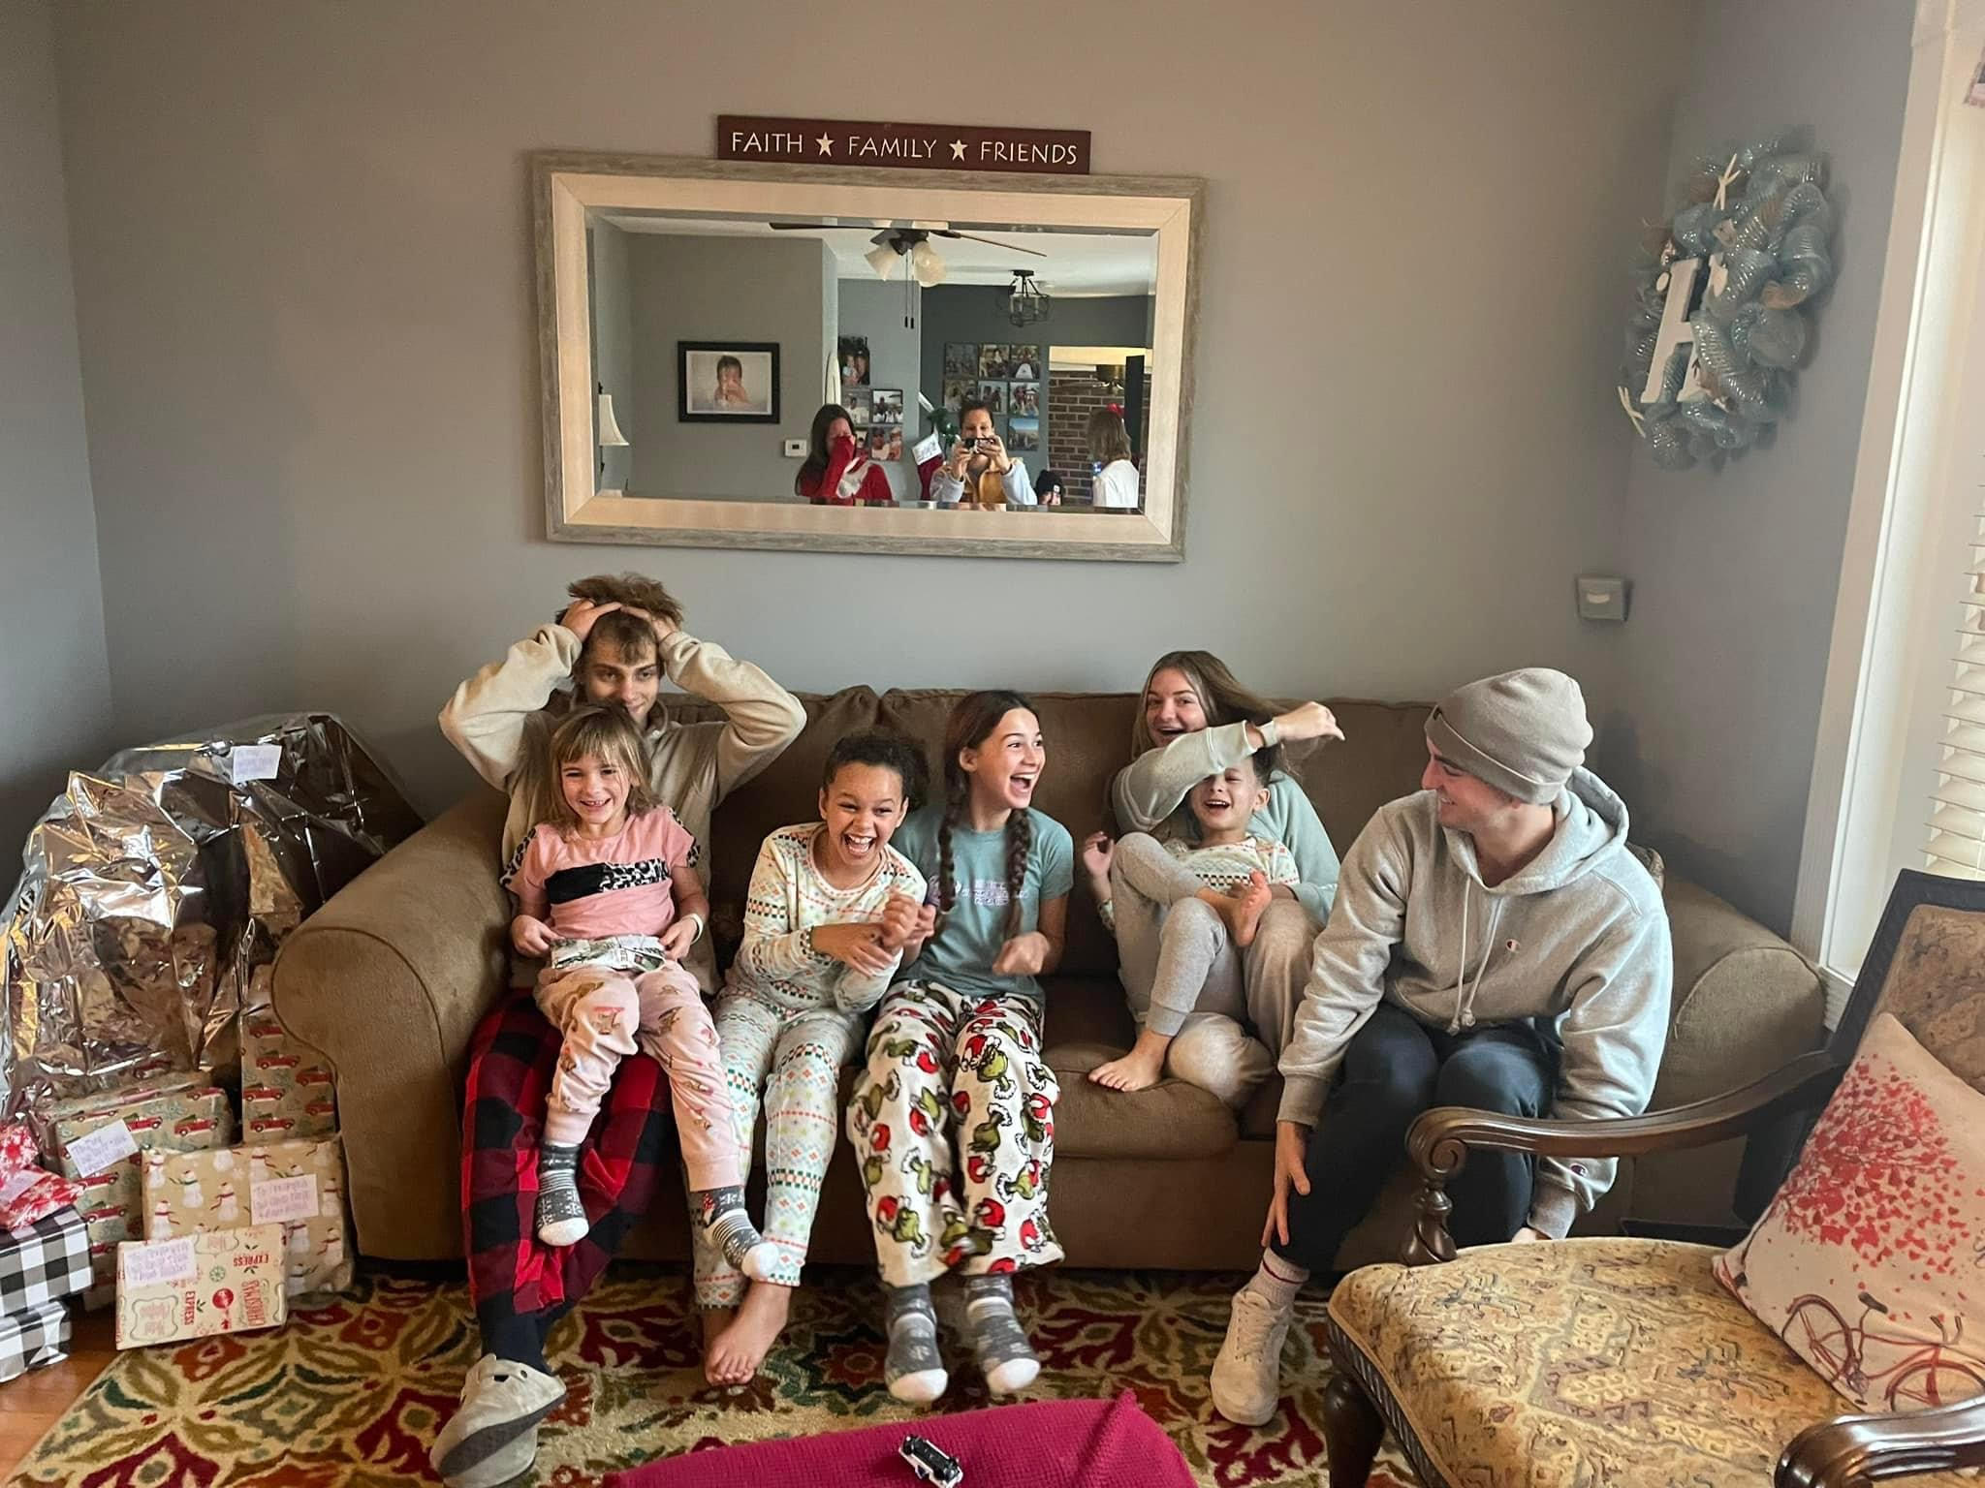
We spend a lot of time with family and friends. For us, it’s truly about slowing down from the busyness and demands of life and being fully present with the ones in front of us.

Our Community (home, neighborhood, church)
Our home
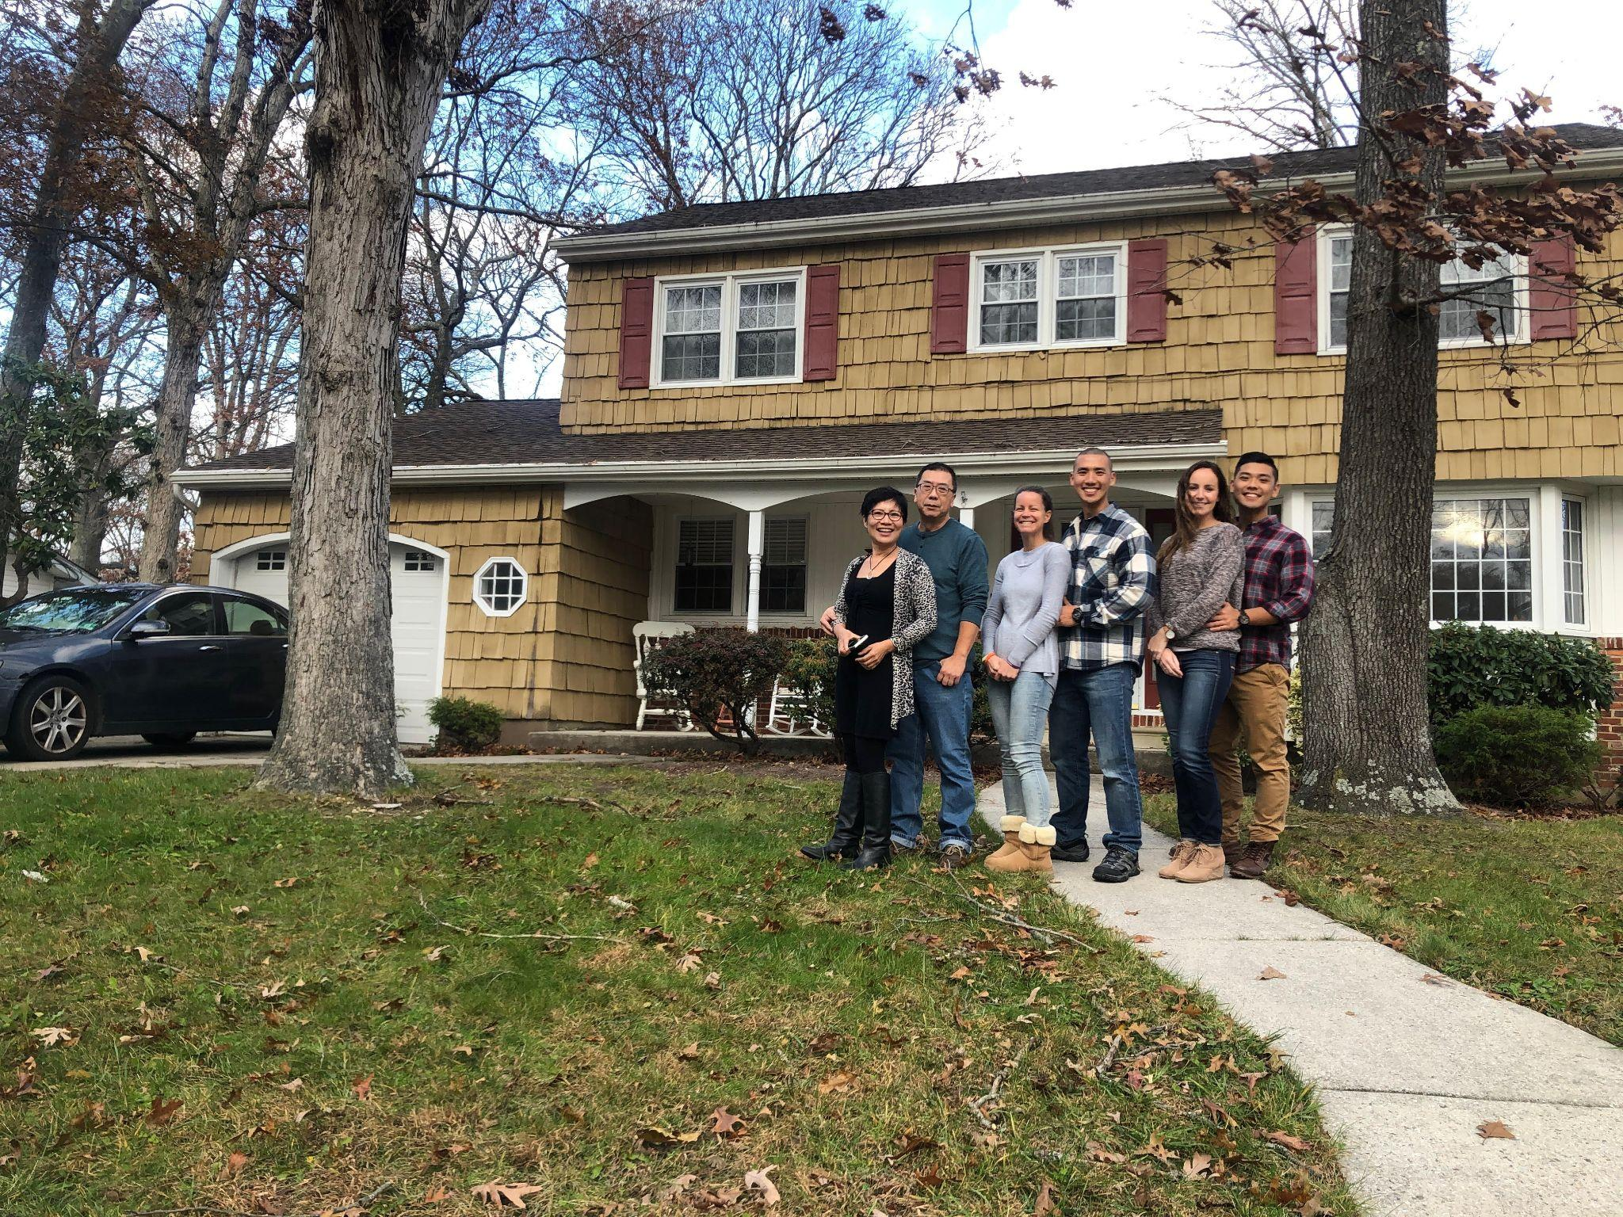
Meg is the visionary behind the look and feel of our home and together we labor to turn her ideas into reality. Our bright, airy, open and spacious 2-story single house is a result of countless hours of hard work to create a welcoming and comforting space for our family to retreat to after a hard day of work. On the first floor, beyond the oversized living room with a set of white, comfy couches and a thanksgiving-size dining table, there is a dedicated playroom with dollhouses and board games that is a favorite for our nieces and nephews when they visit. Looking out the kitchen window, there is an open grassy backyard with tall oak trees on either side and one hanging tree that blooms beautiful pink flowers every April.
Thanksgiving 2019 in front of our home
Upstairs, besides the master, two guest rooms and a hall bath, there is a dedicated nursery room with two large windows looking over the wide front lawn.
Walking out the front door on the left, past two homes is a park with a fishing lake with a walking trail surrounding it. On the one side is a fun playground with picnic tables and on the other side is the municipal building with the police and fire department.

Our Neighborhood

We know all our neighbors on our street and frequently visit with them. God has surrounded us with truly wonderful and caring people. It’s not unusual for one of us to retrieve mail or take out the trash cans when the other one is away. When fresh snow covers the streets, we make sure each other’s driveways are plowed. Derek has done HVAC, plumbing and carpentry work for nearly all the neighbors on our street.
We are very intentional in our relationship with the neighbors on our street, we make it a point to frequently visit with them. Across the street live a wonderful semi-retired couple; the husband loves to keep his car looking shiny and the wife welcomed us with a big bouquet of flowers when we moved in. She came and spent many hours with Meg during her post-surgery recovery. Right next door is a “dog mom” with a big heart. Sometimes, out of the blue, she would leave a container of freshly baked brownies on our porch just for our enjoyment. A retired nurse lives 3 doors down and she is always out walking her mild-mannered Pitbull every morning and afternoon, the dog refuses to keep walking until she gets pat by us. To the left of us live a fun couple; he is an international flight attendant and she is a dance teacher.

Our Church

We have been a part of our home church since college and we are beyond grateful for the faithful men, women and kids that do life together with us. Since day one, we were warmly welcomed and made many friends who have been our special constant companions through numerous trials and heartaches. This community of believers embodies the true teachings of Jesus. Love, grace, mercy, justice, forgiveness and kindness are not only words thrown around from the pulpit on Sundays but everyday values we strive to live by. Young children make up a large part of our church, there is an active Sunday school program led by volunteers to serve them. Several families have lovingly embraced foster and adopted children into their home, our own pastor and his wife have 4 biological and 5 adopted kids.
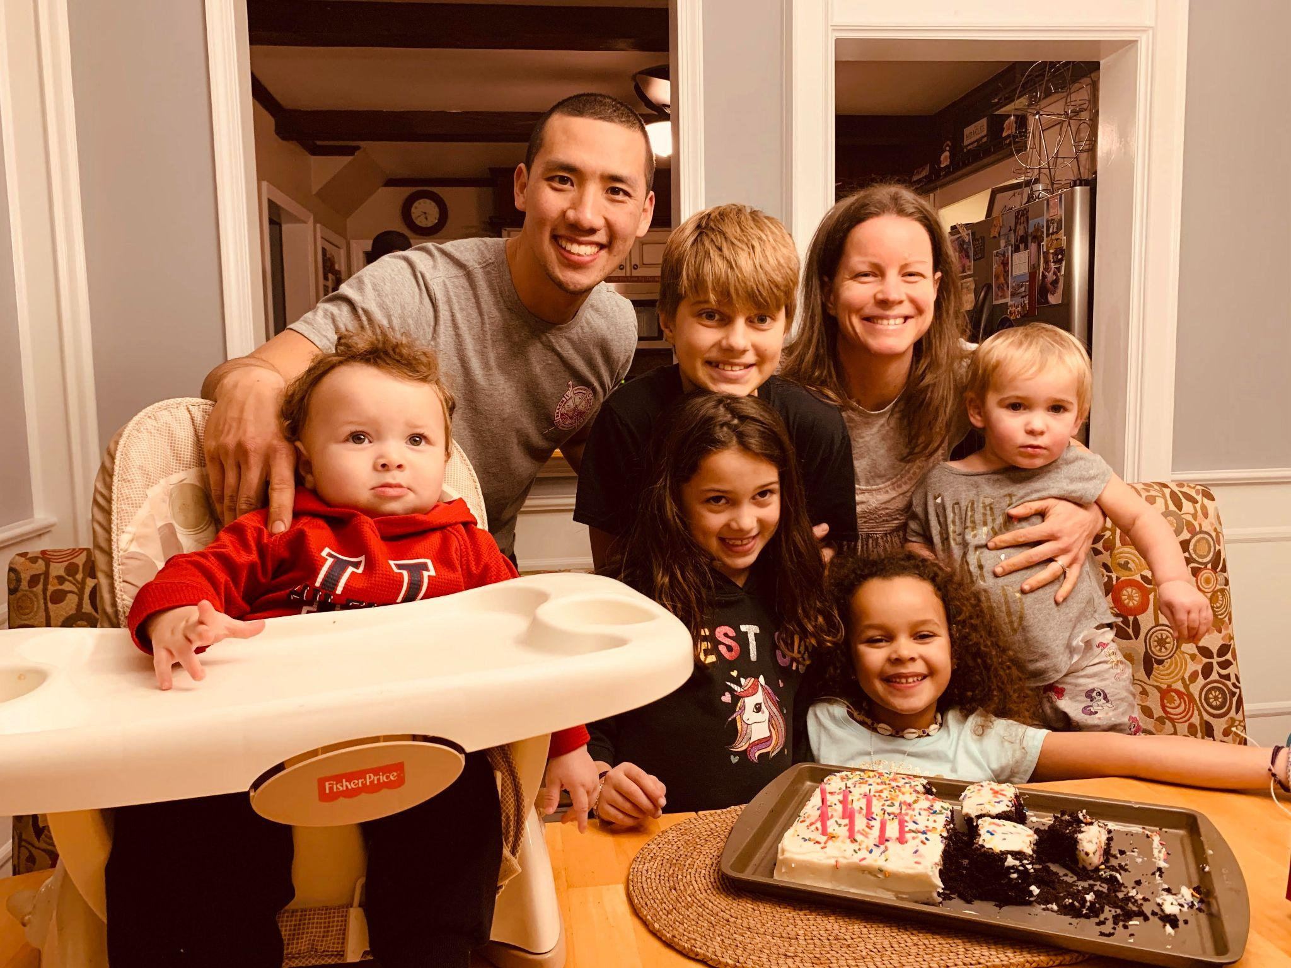
Our Parenting Values

Meg and I seek to create an environment in our home and family where our faith in God is our foundation. This child would have every opportunity to learn that they are wonderfully made by God, personally pursued by Jesus and may be filled with the Holy Spirit.
We understand that as parents, the weight and responsibility of being a steward of this precious gift entrusted to us. We want them to know that they will be so loved by us, our large family and most importantly, God Himself, who will always and forever be with them.
Our vision for this child would be that they would be able to grow in relationship with us as earthly parents but more importantly, for them to encounter and have a closer relationship with their heavenly Father. Nothing matters more to us than the state of their hearts.
All that we do will point back to this vision. We would tirelessly give them our time, care for their physical and emotional needs, be intentional in every interaction, help promote their sense of wonder, instruct them in the way of the Lord, teach them tangible skills and develop character traits so they grow into the fully matured version of what God has intended for them to be. We will, with God’s help, aim to model an example of a life well lived, serving God by loving on the people around us with our unique gifts and talents.
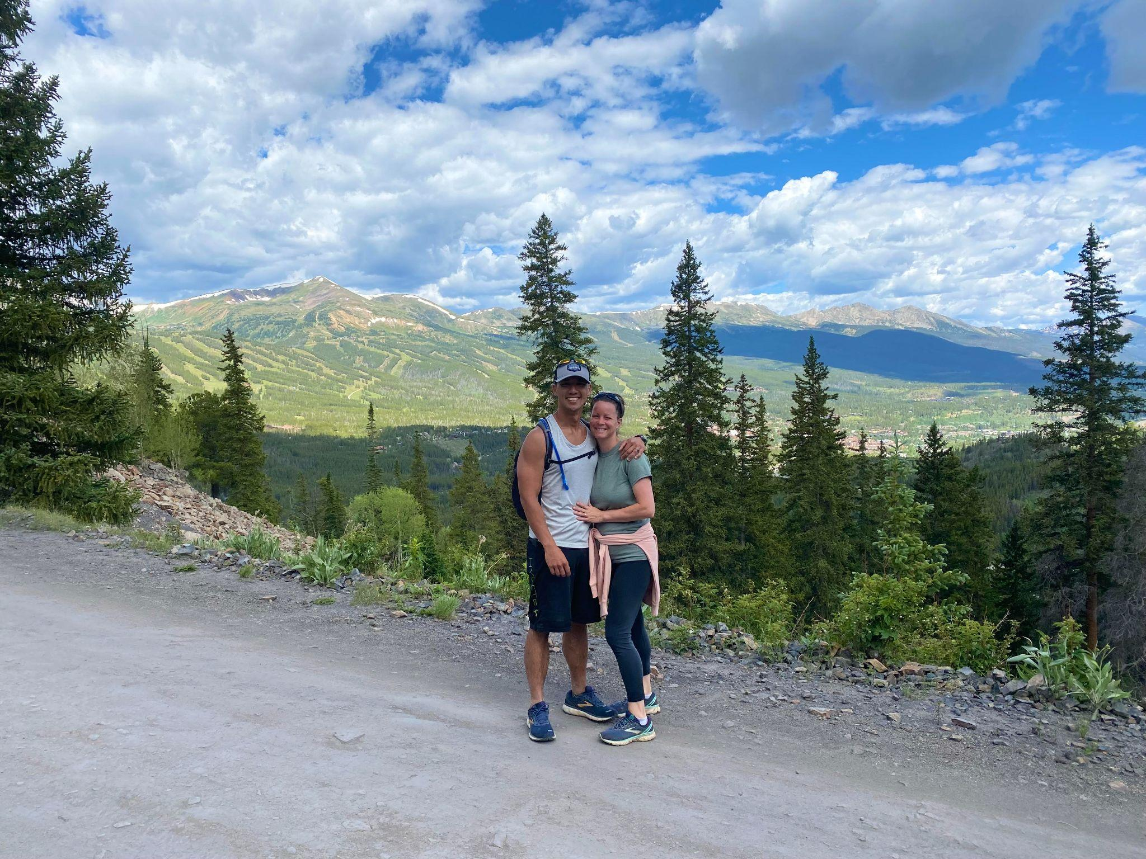
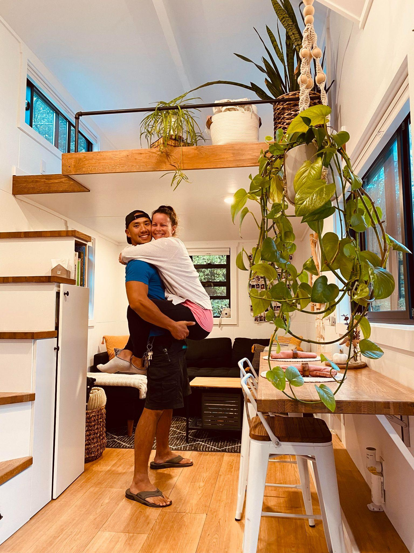
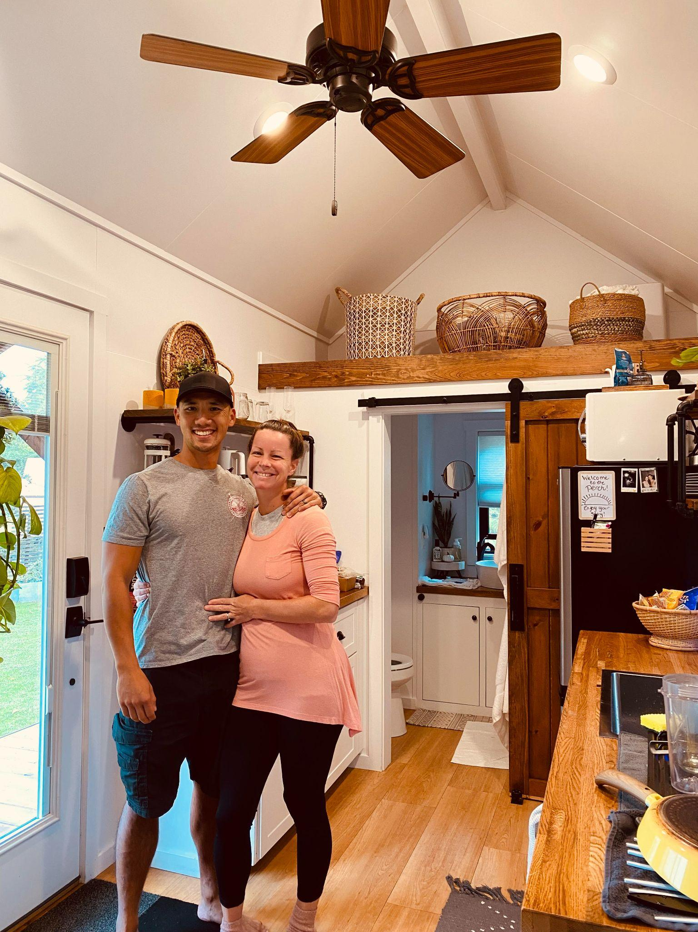
We are so excited to have the chance to share our everyday lives with this new person; surrounding them with a loving supportive community, introducing them to all their new fun and wild cousins, dipping their toes in the cool ocean water in Ventnor, setting up a cozy movie theater at home, baking homemade chocolate chip cookies, feeling the breeze in their face on a beautiful bike ride and venture into an unforgettable road trip to new unexplored places.
Adventures of staying at a tiny house!

“Birth of a new dream”

The rain has been pouring since late last night. It was one of those dreary, dark rainy days that you almost forget what the sun looks like. Not much was said during the car ride through the wet streets and highways, sounds of water splashing against the mud flaps filled the space. Both our hearts were heavy in anticipation of arriving at our destination.
I pulled into the empty lot and parked our SUV. Meg threw on her rain jacket and I did the same. We swiftly stepped out of the car and started walking towards the wooden arch entrance, avoiding massive puddles forming around us.
It’s been a year since the hysterectomy, Meg and I were back in the garden where we first submitted ourselves to that heart-wrenching decision. The solution that cured her prolonged bleeding and suffering was also a decisive and painful end to our old vision of traditional familyhood. It was a strange sensation, feelings of joy and gratitude from the relief of physical pain bombarded by waves of pain and sorrow of a lost future never to become reality. The end of the journey of suffering through constant bleeding and pain brought forth a new journey of being barren and searching for other possibilities to realize the dream of having children.
As we rounded the corner and came up to the historical family estate house, masterfully crafted with finely finished stones on its exterior. Meg spoke up, “I remember that person,” I gazed at her, standing on the stone paver front porch in front of the house, streams of rainwater repelling off of her royal blue raincoat. “The girl that was here, I can see her so vividly. I remember how she was feeling, what she was thinking,” she continued, describing the past version of herself that still had her womb, wrestling with a near impossible decision, “...felt like a lifetime ago.” “Yeah,” was what I was able to respond with, reflecting back on this past year of ups and downs.
My interior voice grew loud. Was it necessary for her womb to be torn out and our future forever altered in order to preserve her life and health? Did we have a choice? Why did God allow for a situation like this to happen to us? Was there another way? The same questions that we grappled with time and time again this past year all came rushing back.
But now a steady, calm and loving voice responds, She is healed, healed from years of painful, dangerous and embarrassing bleeding. I am with you and I have always been with you and I will always be with you.
At the moment, I was grateful for the truth of God, reminding us again that nothing that’s ever happened to us or anyone for that matter, is ever in vain. Drawing on His strength, we did start to pick up the pieces as we began the journey of adoption in hopes that the God of redemption may redeem the brokenness in our story.
We have heard from the Bible that God is always with us, especially in the midst of the darkness and pain. But now we have truly felt God’s hand on our shoulders as He guided us through the valley of the shadow of death.
The people of God have never been shielded from the realities of the brokenness of life in this world. Men, women and children of faith through the centuries had their fair share of trouble, heartaches and unfulfilled dreams. Many have cried out to God, some had their prayers answered exactly the way they prayed, others came to learn that what they had asked for actually wasn’t what was best for them. Many times, the death of one dream gives rise to another far better dream.
Maybe God had something else in store for us. Something that is far greater than we can ever hope or dream. Maybe we needed to let go of our old dreams so that He could come and give us a new one, our hands needed to let go so that they are free and open to behold what is new and better.

Message to expecting birth mom

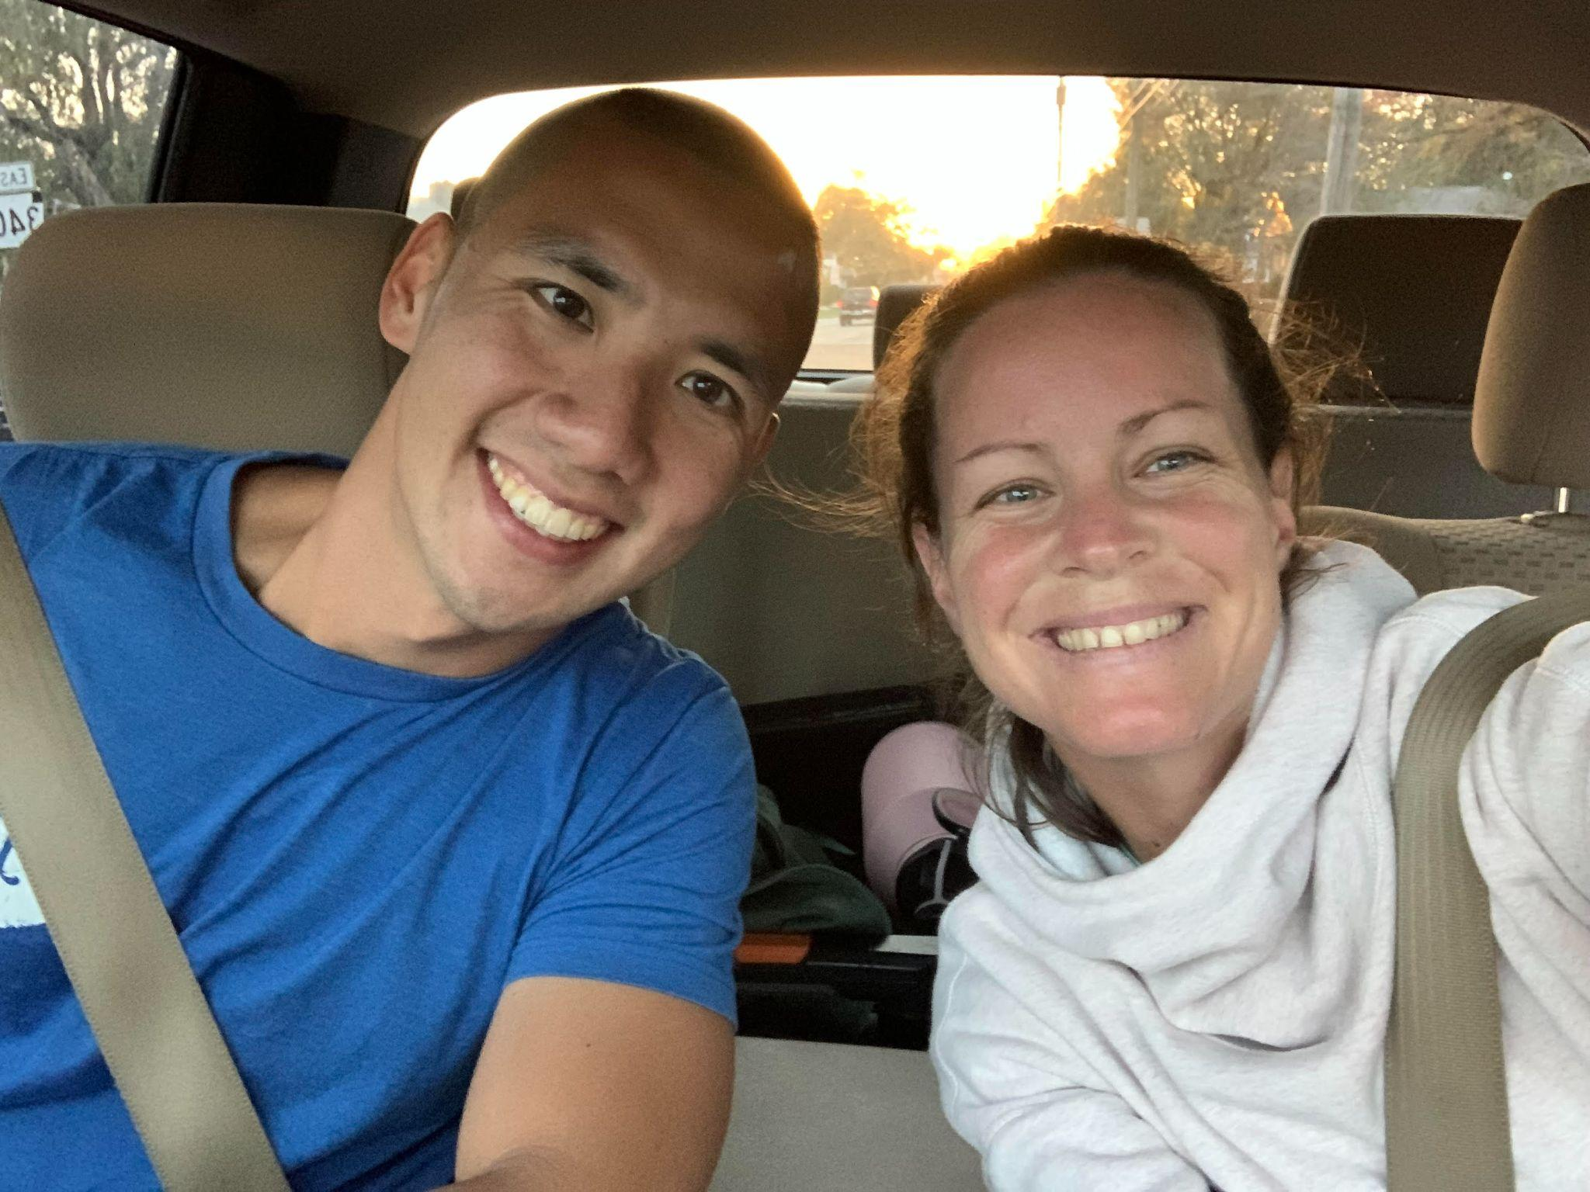
We can’t begin to fathom how incredibly difficult this is for you, which is an understatement. We want you to know we are praying for you as you are faced with making these monumental life altering decisions. Maybe the future you had originally had in mind is now forced to be changed. We pray that you may trust God with what He is doing and take this journey with us. May you continue to listen for God’s voice of guidance and truth. We hope to hear from you.

Love,
Derek and Megan

